NAME ………………………………………… INDEX NUMBER ……………

CANDIDATE SIGNATURE………………

DATE …………………………………..
231/2/
PHYSICS
PAPER 3
JULY/AUGUST 2019
2¹/₂ HOURS
BUURI EAST STANDARDS
Kenya Certificate of Secondary Education
PHYSICS PAPER 3

INSTRUCTIONS TO CANDIDATES.
- Write your name and index number in the spaces provided above.
- Sign and write the date of the examination in the spaces provided.
- You are supposed to spend the first 15 minutes of the 2¹/₂ hours allowed for this paper reading the whole paper carefully before commencing your work.
- Marks are given for a clear record of the observation actually made, their suitability, accuracy and use made of them.
- Candidates are advised to record their observations as soon as they are made.
- Non-programmable silent electronic calculators may be used.
- Candidates should check the question paper to ascertain that all the pages are printed and that no questions are missing.

FOR EXAMINERS’ USE ONLY

Questions | Maximum score | Candidate ‘s score
 | 14
 | 26
TOTAL

1. a) You are provided with:
- One voltmeter with a scale of 0 - 5V.
- One ammeter (0 - 2.5A)
- Six connecting wires(three with crocodiles clips at one end )
- Two dry cells.
- Cell holder.
- Nichrome wire mounted on a scale.
- A micrometer screw gauge.
- Switch.
- Proceed as follows.
- Measure the thickness of the wire using the micrometer screw gauge provided.
d= ……………….. m (1mk)
- i) Set up the apparatus as shown in the circuit diagram below. (AB is the nichrome wire).
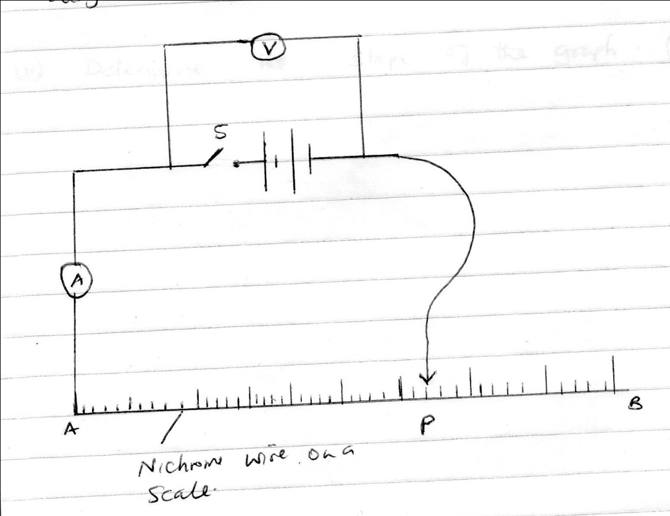

ii) Adjust length AP of the nichrome wire to 80cm using the crocodile clip at P. Now connect the crocodile clip next to the switch and record the voltage and ammeter reading in the table below.
Length AP (cm) | 80 | 70 | 60 | 50 | 40
P.D(V)
Current (A )

iii) Repeat b(ii) for lengths 70cm, 60cm, 50cm and 40cm and enter the reading in the table above. (5mks)

- Plot a graph of p.d against current. (5mks)

- Determine the slope of the graph. (3mks)

2. a) You are provided with the following:
- A metre rule
- A spring balance
- A weight of 2N with a hook or (two 100g masses)
- Stand
- Knife edge support.
- Two light strings about 10cm long.
Proceed as follows:
- Using the string provided make two loops to be used as hooks L1 and L2 in the diagram.
- Suspended the spring balance from a clamp and using one loop to support the rule from the spring so that the loop L2 is on 85cm mark.
- Support the other end of the rule with a knife edge at the 10cm mark so that the rule is horizontal.
- Using loop 1 suspended the 2N weight at a distance d=10cm from the knife edge as shown and take the reading of the spring balance, record the results in the table.

- Adjust the distance d to 20cm,30cme.t.c and each time recording the reading of the balance to complete the table. (5mks)
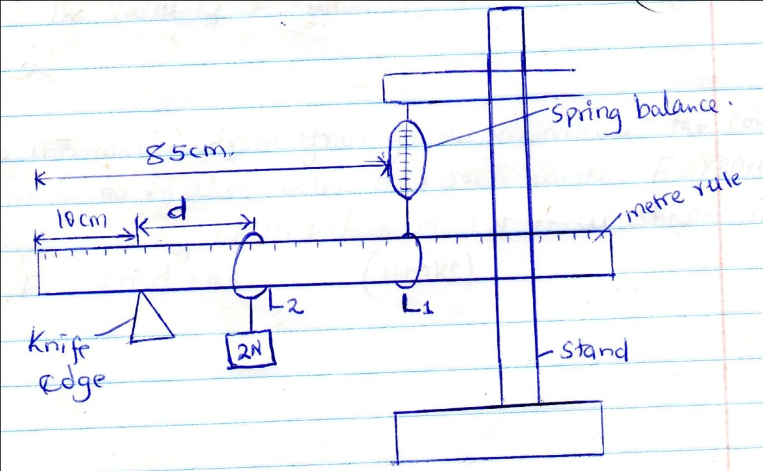
RESULTS

Distance (d) | 10.0 | 20.0 | 30.0 | 40.0 | 50.0 | 60.0 | 70.0
Force (N)

- Plot a graph of force F against distance d(cm) (5 mks)

- From your graph determine:
- The slope (2mks)

- The value of F when d=0 (2mks)

- Using the information from your graph, determine the constant k and m in the equation below and state units, f represents the reading of he balance and d is as shown in the above. F=2md +40k. (4mks)
b) You are provided with the following
- A candle
- A lens and a lens holder
- A screen
- A metre rule

- Set up apparatus as shown in the figure below ensure that the candle flame and the lens are approximately the same height above the bench.
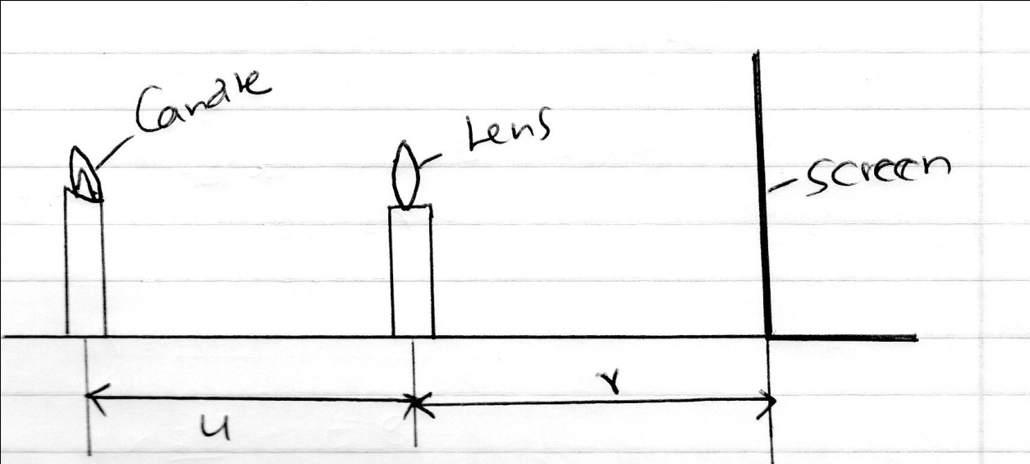
- Set the position of the lens so that it is 40cm from the candle (u=40cm). Adjust the position of the screen until a sharp image of the candle flame is obtained. Measure the distance (v) between the lens and screen. Record the value of v in the table below.
- Repeat the procedure in (b) above for the other values of u in the table (b) below. Complete the table(4mks)
Table b)

U(cm) | 40 | 45 | 50
V(cm)

Magnification m=v/u
- Given that f = v where f is the focal length of the
M+1
Lens, use the results in the table above to determine the average values of f. (4mks)

