232/3/
PHYSICS
PAPER 3
JULY/AUGUST 2019
BUURI EAST STANDARDS
Kenya Certificate of Secondary Education
MARKING SCHEME

- a) d= 0.045 m ± 0.003
ii)
Length (cm) | 80 | 70 | 60 | 50 | 40
p.d (v) | 2.65 | 2.55 | 2.50 | 2.45 | 2.35 | ±0.2
Current (a) | 0.25 | 0.28 | 0.32 | 0.38 | 0.42 | ±0.02

Slope = p.d (v)√ = 2.9 – 2.45√ = 0.45 = -0.15Ω
0.5 – 3.5 -3
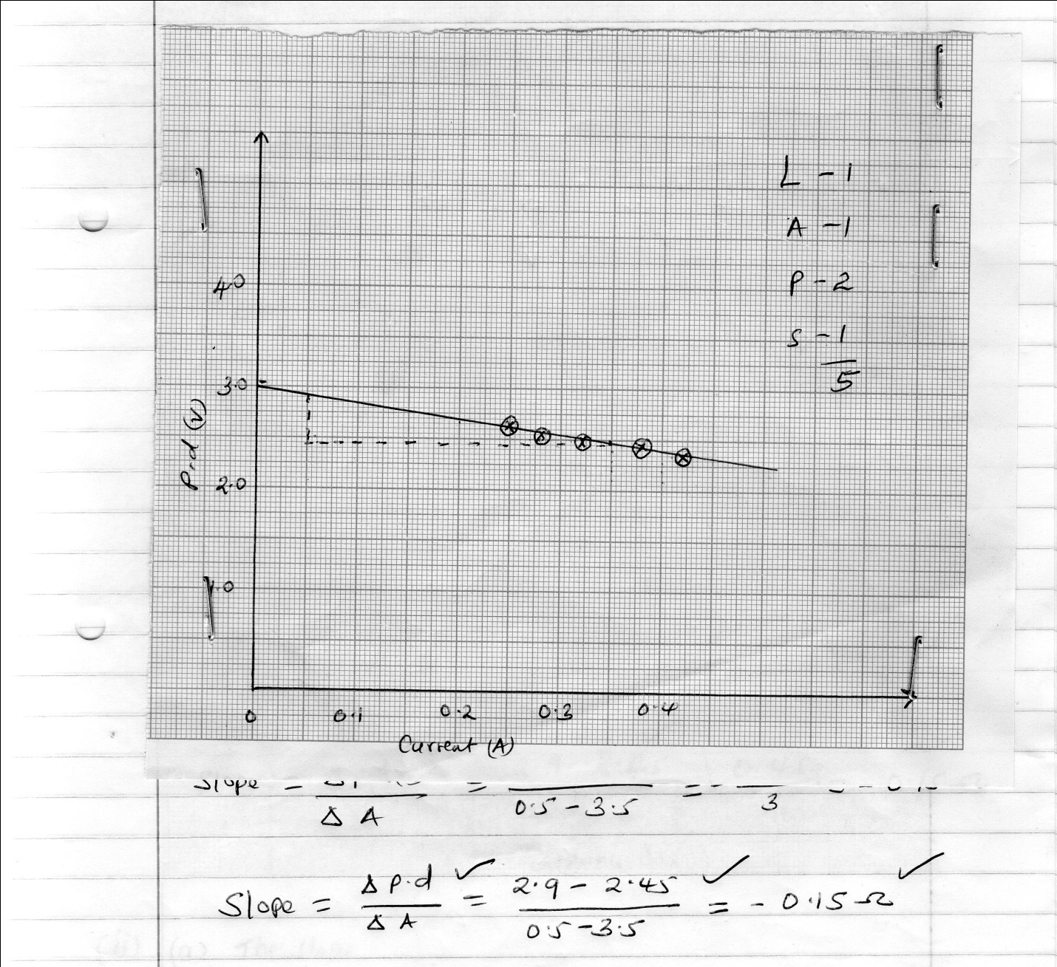
2. a)
Distance (cm) | 10 | 20 | 30 | 40 | 50 | 60 | 70
Force (N) | 0.8 | 1.0 | 1.2 | 1.2 | 1.8 | 2.0 | 2.4 ±0.01

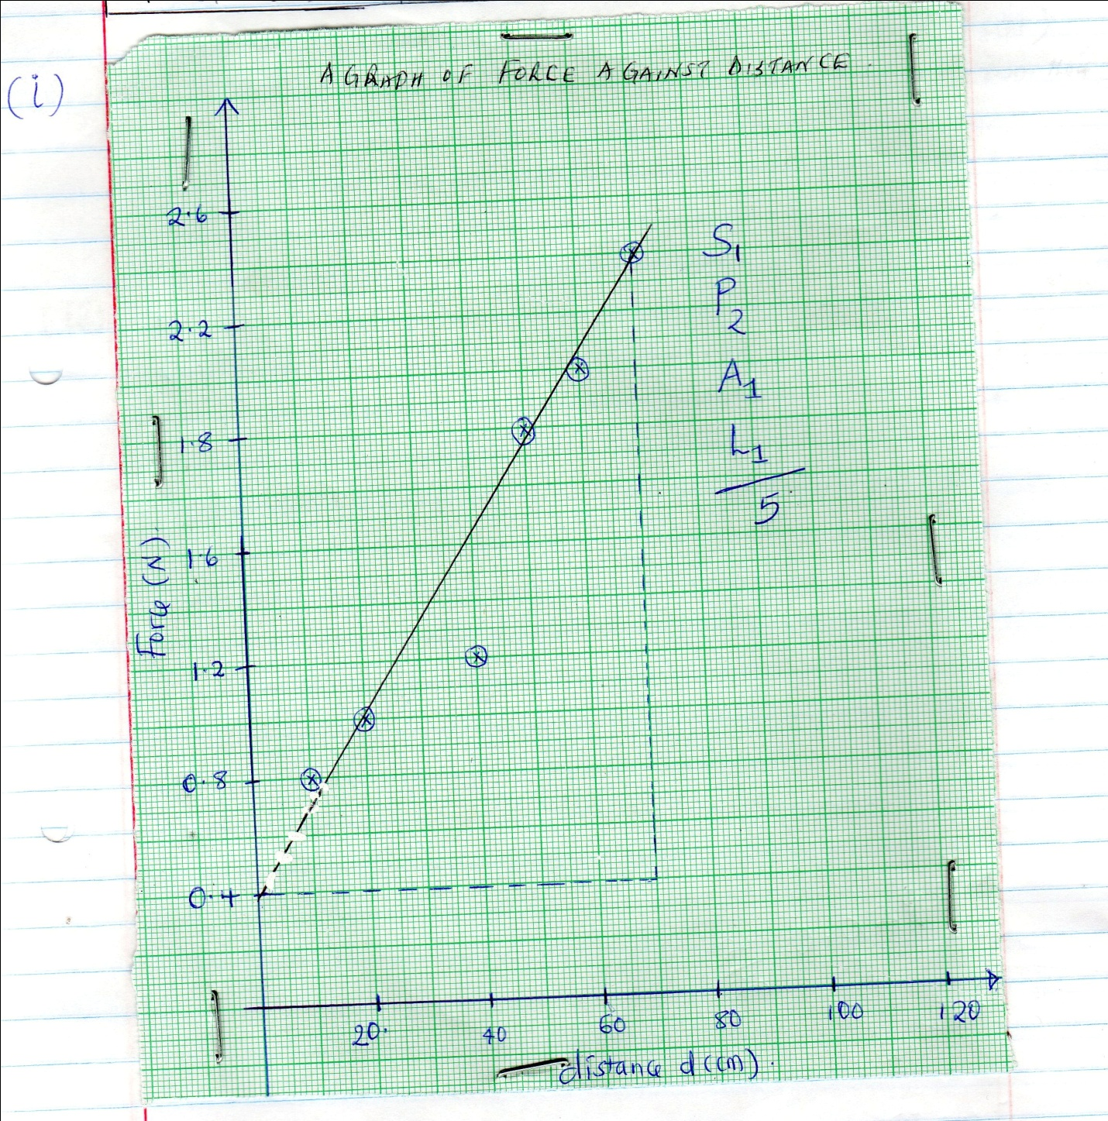

ii) The slope
(0, 0.4) (70, 2.4)
= 2.0
70 x 10⁻²
= 2.857 N/cm
Or 2.857 x 10⁻² N/M
b) When d = 0 , Force = 0.4N i.e the y – intercept
(1mk for identify it’s a value for y – intercept)
(1mk for correct reading from the graph)
Iii) Comparing y=mx+c with F = 2md +40k
Then gradient = 2m
2.857 = 2m
2.857= m
2
Y= intercept = 40k
= 0.4 = 40k√
40 40
= 0.04
40
  - N√

2. Table (b)
U (cm) | 40.0 | 45.0 | 50.0
V (cm) | 41.0 | 36.0 | 34.0
Magnification m=v/u | 1.025 | 0.8 | 0.68

F= v
M+1
f₁ =41= 20.25 cm f₂ = 36 = 20.0cm√ f3 ₌34= 20.24 cm√
2.025 1.8 1.68

F = 20.25 +20.0 +20.24 60.49 =20.16 cm√
3 3

