3KNT FRATERNITY EXAMINATIONS
PHYSCIS PAPER 3 MARKING SCHEME

Question 1
a)i) Diameter “d” = 1.7cm ± 0.1cm (1mk)

ii) Radius “r” = 0.85cm (1mk)

b)i) M = 5.8g ± 0.6g (1mk)

P = 0.4 X 5.8 (0.85)² = 1.676 (1mk)

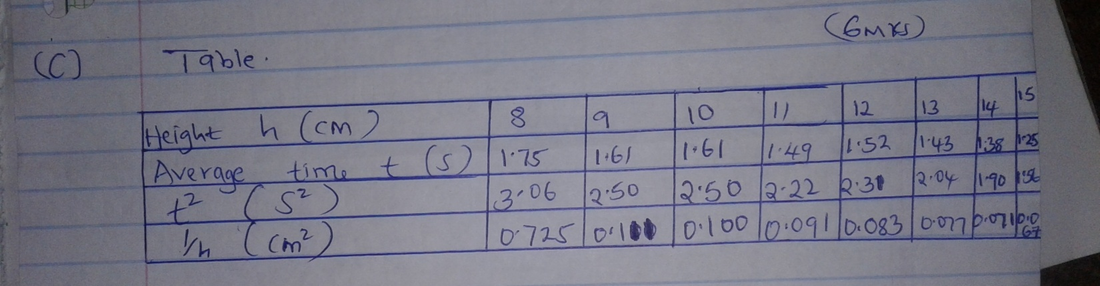

1c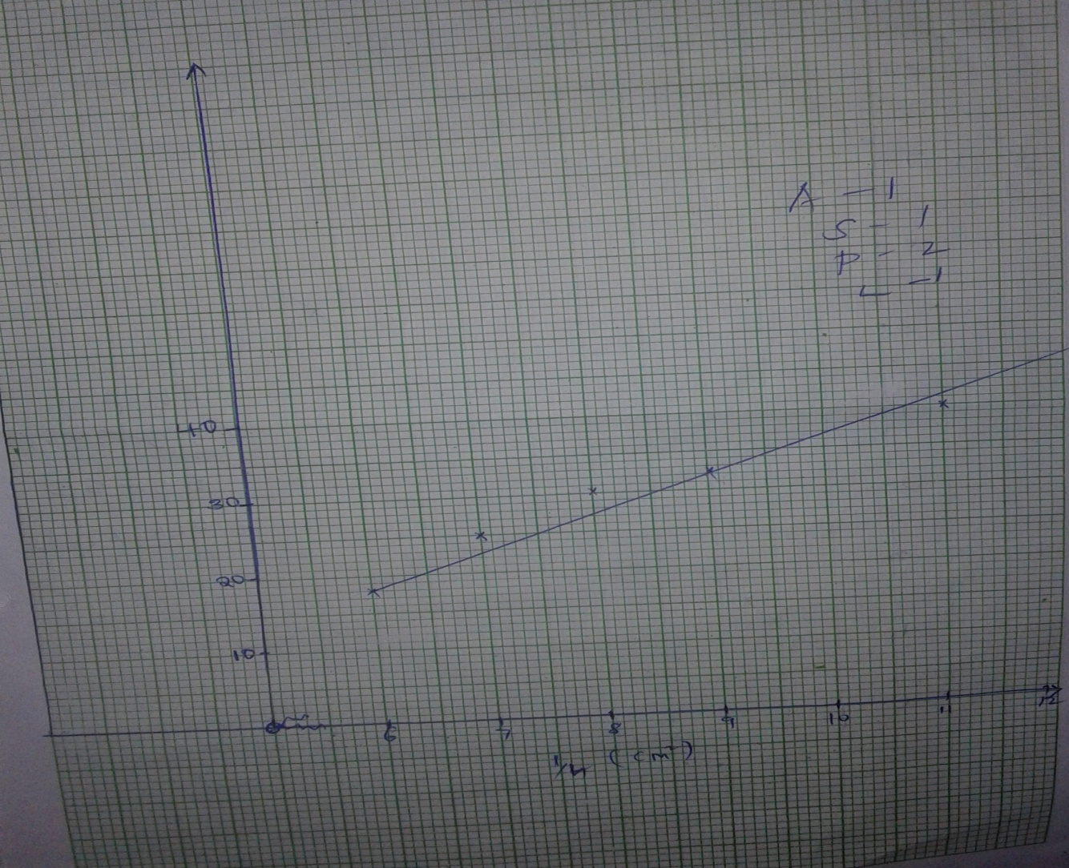

d)i)

ii) S = 1.25 x 10⁻⁵ (3mks)
3.2 x 10⁻⁵

= 12.5 x 10⁻³
3.2

= 3.91 x 10⁻³

iii) G = Mr² (5 – 1) (2mks)
20

= 5.8 x 0.85² (3.91 x 10⁻³ – 1)
20

= 5.8 x 0.7225 x (0.1955 x 10⁻³ – 1)

= 4.19

Question 2

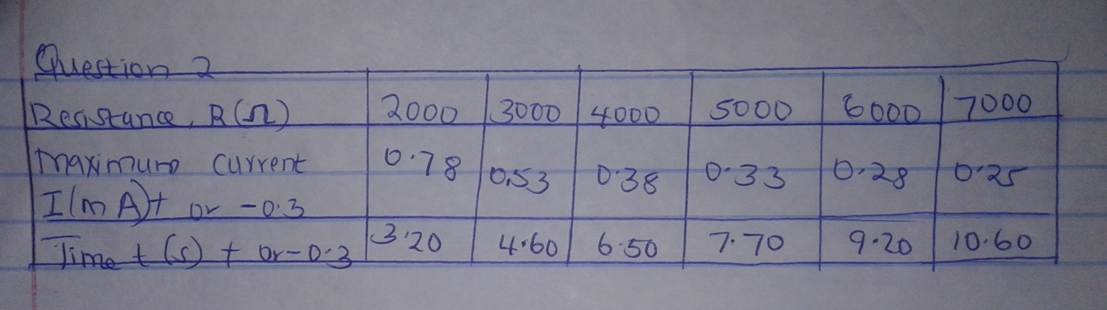

e)i) Graph of R ( ) against t (s)

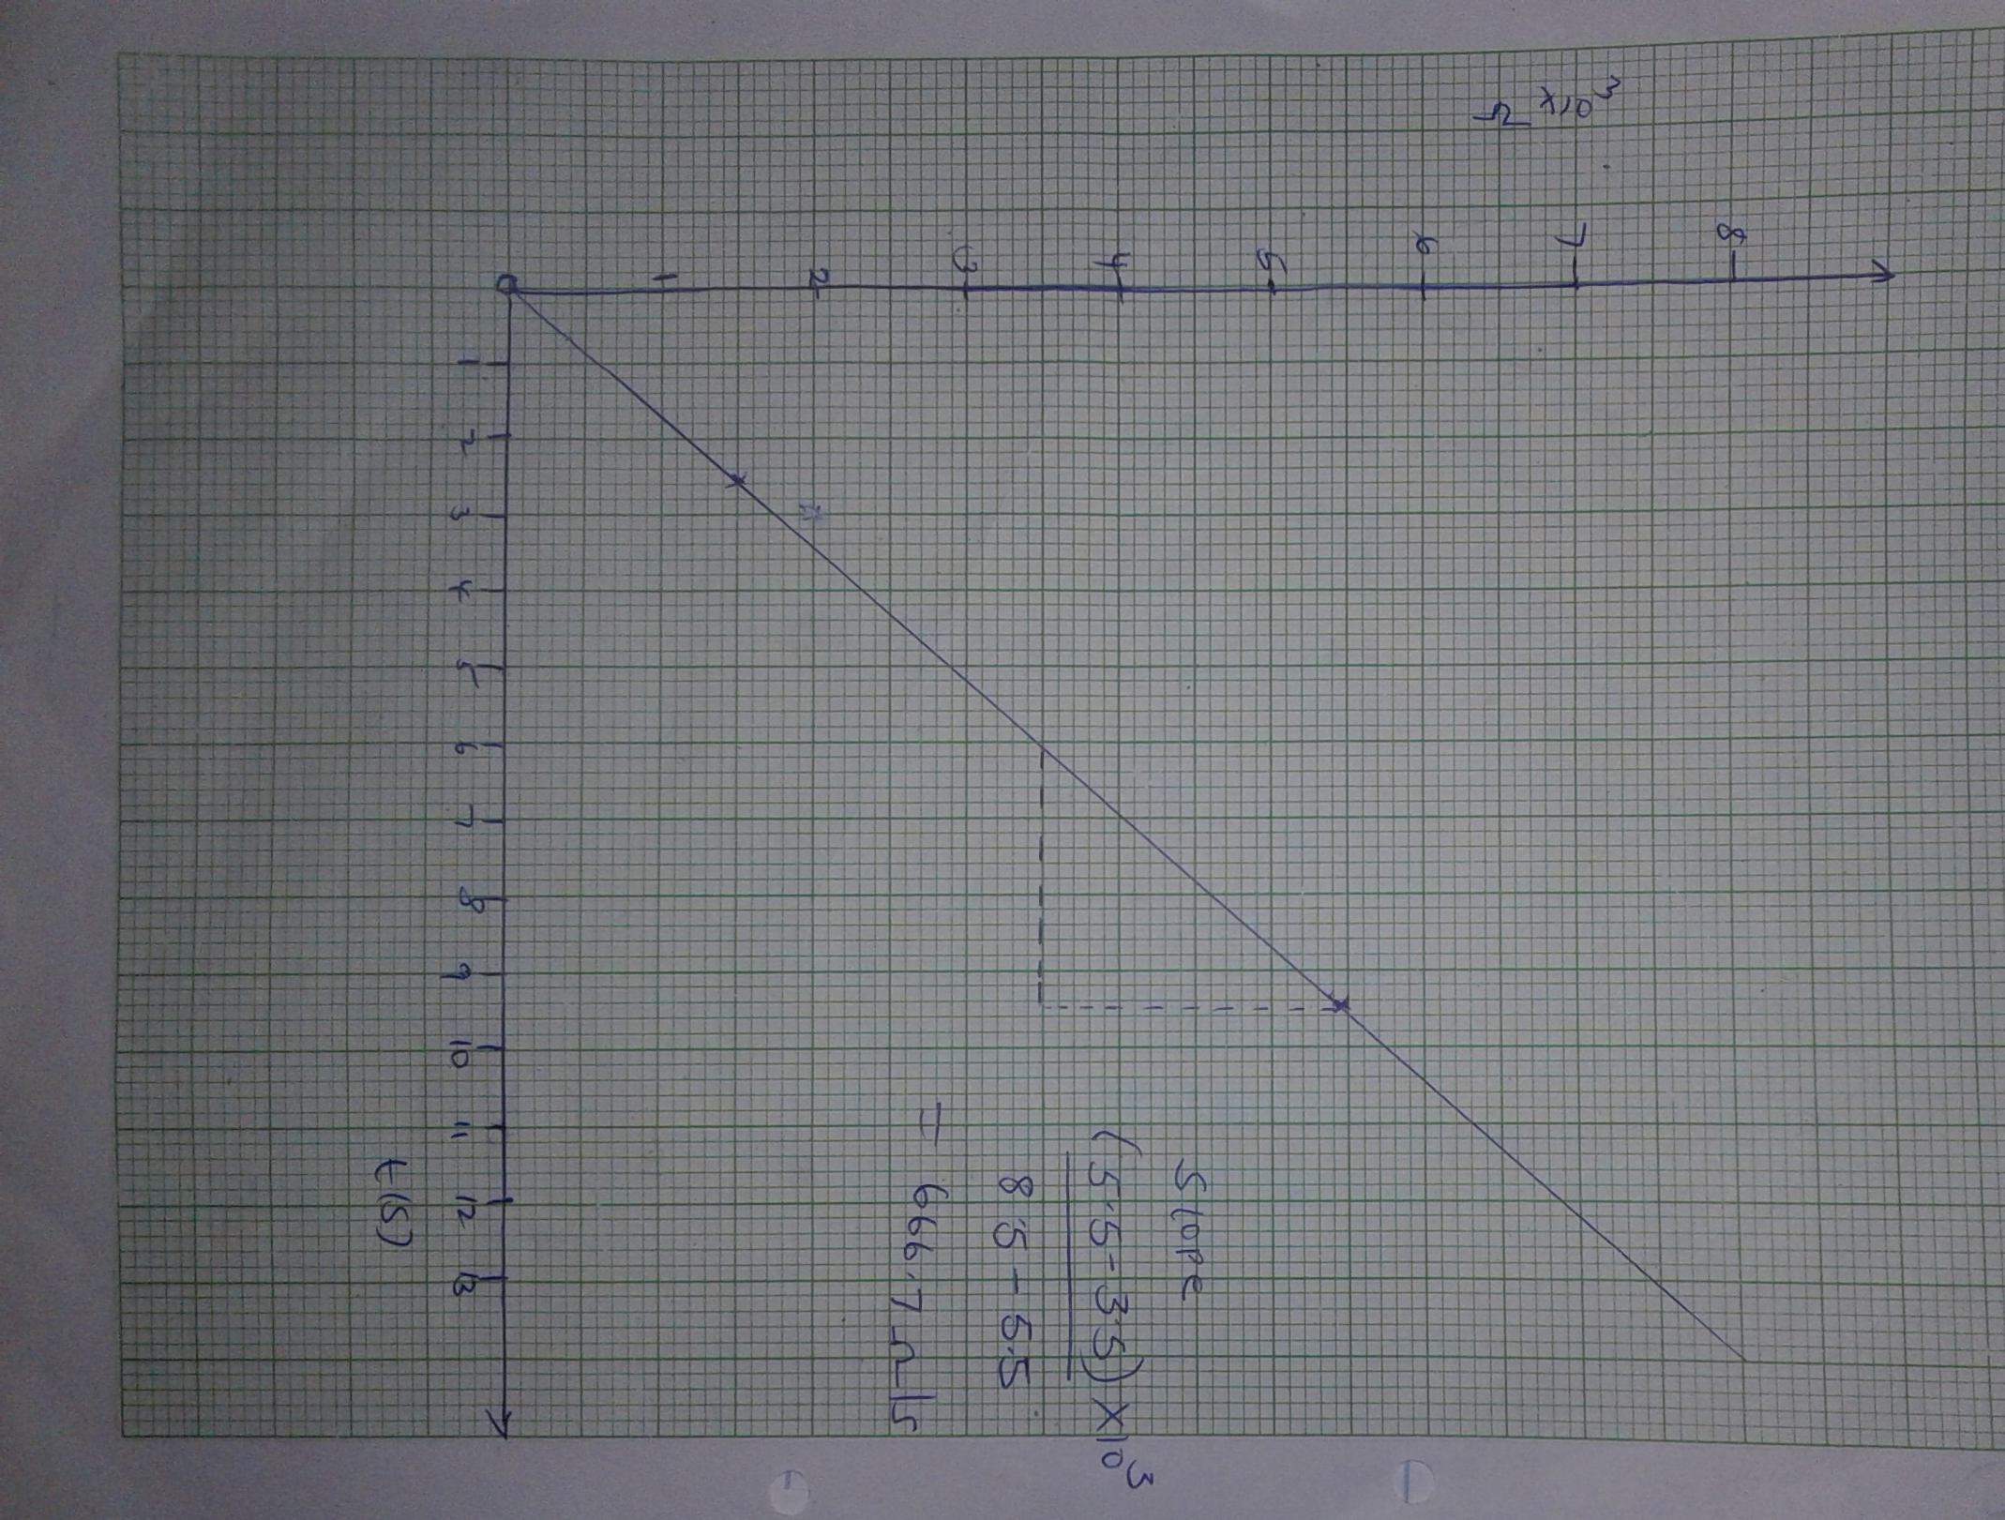

ii) Slope = 666.7 /s

iii) Given R = t
constant k

$1/k$ = Slope
= 666.7

K = $1/{666.7}$

K = 0.0015s/

f) To discharge the capacitor.

