3KNT FRATERNITY EXAMINATIONS
PHYSCIS PAPER 1 MARKING SCHEME

1. P = $m/v$

= 50.1
16.7
= 3 cm³ (indicating the level – 13cm³)

2. V2 = U2 + 200
V2 = 0 + 2 x 1.5 + 200
V = $\sqrt{600 }$ = 24.495

Momentum = MV
= 200 x 1000 x 24.495
= 4.899 x 10⁶ kgm/s

3. Length of the inclined plane
Angel of inclination
Friction force. (any two)

4. Upthrust = 0.5 – 0.5
= 0.2N
Volume of displaced water = 0.2
100 x 10
= 0.0002m³

Density of glass = $m/v$

= ${0.5}/{0.00002}$

= 2500kg/m³

5. The centripetal force is equal to weight of water.

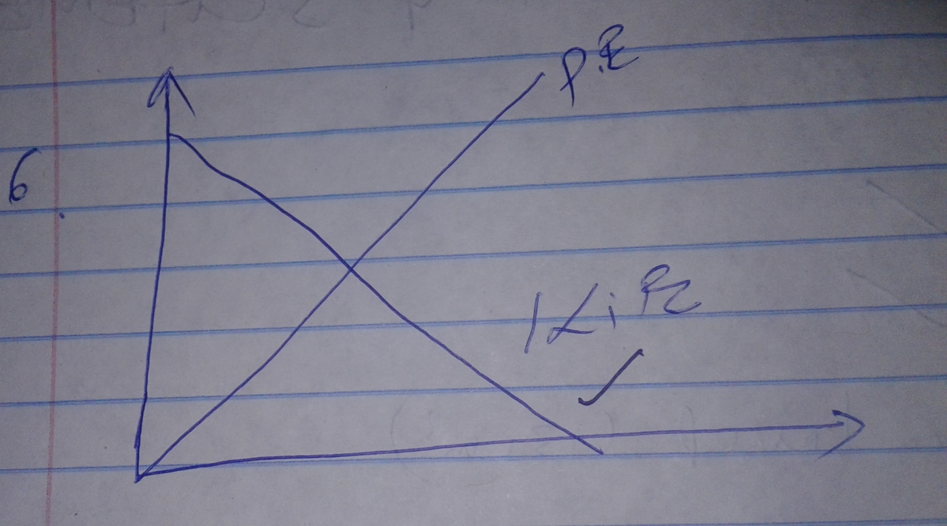

7. Detergent reduced the surface tension.
8. Pressure =
= 0.26 x 13600 x 10
= 103360Nm⁻²

9. When heated the gas inside the cylinder expands. Therefore the gas pressure increases.

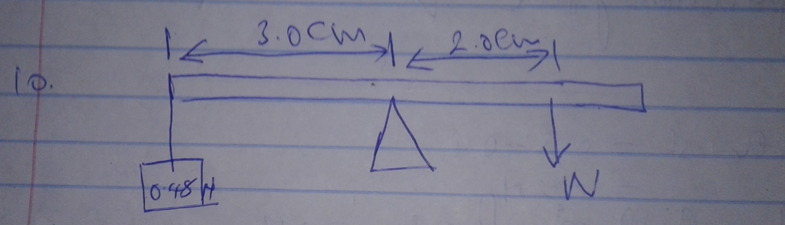
At equilibrium
Clockwise moment = Anticlockwise moment
W x 20 = 0.48 x 30
W = 0.48 x 30
20
= 0.72N

11. Heat lost = heat gained
2 x 4200 x ( - 20) = 9 x 4200 x (20 - )
= 20 = ${90}/3$
= 30 + 20
= 50⁰C
12. The moment of the weight of the cone is towards the right. (clockwise moment direction)

13. Reading = M ( g + a )
= 50 (10 + 2)
= 600

SECTION B
14.I i) Temperature is constant because the absorbed heat is used to change the solid to liquid.

ii) Temperature is constant since the heat absorbed is used to change liquid to gaseous state.

II Specific heat capacity is the quantity of heat required to raise a unit mass by 1 kelvin.

IIIa) Heat gained by Calorimeter
= heat capacity x temp
= 40 x 6
= 240joules

b) Heat gained by water = MCD
= 0.1 x 4200 x (41 – 40)
= 2520joules

c) Heat gained by metal block
= Heat gained by calorimeter + Heat gained by water.
= 2520 + 2340
= 260joules

d) MCD = 2760 joules
0.15 x c x (120 – 46) = 2760
C = 2760
0.15 x 76
= 248.65j

IV - Presence of impurities
- Increase of pressure

15.a) Law of floatation state that a floating body displaces its

b)i) Volume of water displaced V = π r²h.
= ${22}/7$ x ${0.7}/2$ x 0.12
= 0.00462

Weight of disc = weight of water displaced
= 100 x 0.00462 x 10
= 46.2N

Mass of disc = $w/g$
= ${46.2}/{10}$

= 4.62kg

iii) Volume of the disc = π r²h.
${22}/7$ x ${0.7}/2$ x ${0.7}/2$ x 0.24
= 0.000924m³

Density of disc = mass
Volume
= 500kg/m³

iv) Volume of displaced water when fully submerged = volume of disc

Volume of water displaced = 0.00924
Mass of water displaced 1000 + 0.00924
= 9.24kg

External mass = 9.24 – 4.62
= 4.62kg
= 4620g

No. of coins = 4620
10
= 462 coins

17.a) Boyles law

b) R = gradient of the graph

R = 8.0 x 105
(8 – 0)

c) When weight of the sphere is equal to upthrust plus viscous drag.
Weight = upthrust + viscous drag

d)i) Momentum before collision = momentum after collision
(M1 + M2)V = M1U1 + U1 U2
(0.5 + 0.1) x V = (1.5 x 0) + ( 0.1 x 10)
V = $1/{1.6}$

= 0.626 m/s

ii) P.E. = K.E.
Mgh = ½ MV²
H = V²
2g
= (0.625)²
2 x 10
= 0.0195metres

16.a) Brownian motion is random or zig-zag motion of particles.

b)i) Lens – to focus xxxxxx into the smoke cell
smoke – to provide visible particles.

ii) Bright specks in continuous random motion are seen. This is due continuous bombardment of smoke particles by invisible air particles.

iii) The random motion increases.

c)i) Diameter of molecules = Volume of drop
area of patch

= $4/3$ x 3.142 x (2.5 x 10⁻⁴)³
3.142 x 0.1 x 0.1

= 2.0833 x 10⁻⁹m

ii) The patch forms a mono layer.

17.a) Work done = l x h
Mass = 900 x 1
= 900kg
Load = 900 x 10
= 9000N

Work done = 9000 x (8 + 4)
= 108000j

b) Power = Work output
time

= 108000
1 x 60 x 60
= 30w

c) Efficiency
eff = Power output x 100
Power input

30 x 100
240 x 0.2

${30}/{48}$ x 100

= 62.5%
ii) Reducing friction.
Making movable part of the machine lighter

iii) valves leakage

18.a) Temperature
Mass of gas

B)i) (I) 3 X 10⁵Pa (from the graph)
(II) 1 x 10⁵ Pa (from the graph)

ii) As bubble rises the total pressure exerted on the bubble reduces since PV is constant, increases in pressure corresponds to decrease in volume.

iii) Atmospheric pressure = pressure at the top of pond
= 1 x 10⁵ Pa

