MWAKICAN JOINT EXAMINATION
FORM II BIOLOGY END TERM OF TERM II EXAM 2016

NAME: …………………………………………………………………………….. ADM NO: ………………

SECTION A
- Study the diagram below
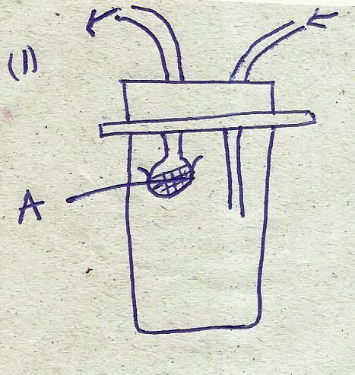

- Name the apparatus (1mk)

- Suggest the use of the apparatus. (1mk)

- Name the part labeled A and state its function. (2mks)

- Name the field of biology that specializes in the study of the following; (3mks)
- Insects

- Interrelationships between organism and their environment.

- Heredity and variations.

- The structure below was observed under the light microscope.
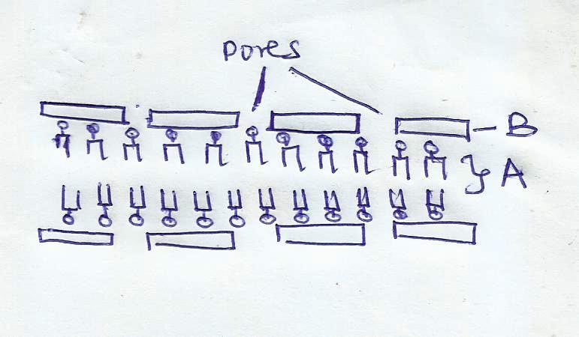

- Identify the cell structure. (1mk)

- Name the parts labeled A and B (2mks)

- State two functions of the above structure. (2mks)

- The diagram below shows a certain cell in living organisms.
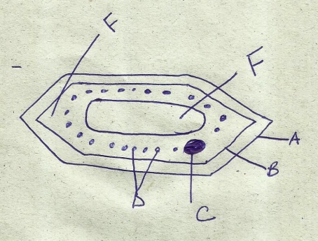
E

- Identify the cell (1mk)

- Give two reasons for your answer (2mks)

- Name the parts labeled; (3mks)

A …………………….. D……………………….
B …………………….. E…………………………
C ……………………. . F………………………..

- State the functions of the parts labeled C, D and E. (3mks)
C…………………………………………………………………………….
D……………………………………………………………………………
E…………………………………………………………………………….
- Name the organelles in a cell which perform the following functions. (3mks)
- Excretion in Amoeba

- Secretion of synthesized proteins and carbohydrates.

- Formation of cilia and flagella.

- The diagram below represents a cross section of a plant part.

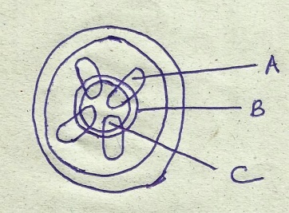

- From which part of the plant was the section obtained? (1mk)

- Name the parts labeled A,B and C. (3mks)

A…………………………….. B……………………….. C……………………..

- What is the function of the part labeled C? (2mks)

- What is transpiration? (1mk)

- Give two importance of transpiration in plants (2mks)

- Name two sites for transpiration (2mks)

- Name the instrument which is used to determine transpiration rate. (1mk)

- Name the : (2mks)
- Material that strengthens the xylem tissue
- Tissue that is removed when the bark of a dicotyledonous plant is ringed.

- Name the blood vessel that transports blood from; (2mks)
- Lungs to the heart

- The aorta to the liver

SECTION B 40 MARKS
- The diagram below illustrates blood circulation in certain organs in humans.
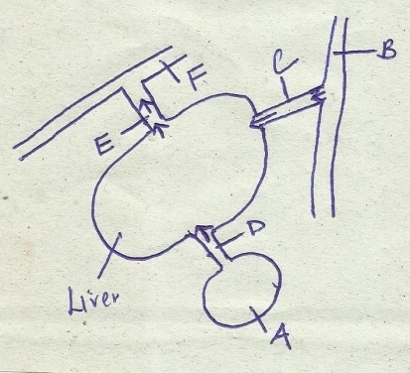

- Name the part labeled A ……………………………… (1mk)

- Name the blood vessels labeled B,D, E and F. (4mks)

B …………………….. E……………………………
D …………………….. F……………………………

- State how the composition of blood in vessel E differs from that in vessel D. (3mks).
E D

- Explain the role of bile in the process of digestion (2mks)

- Below is a diagrammatic summary of the main biochemical events in photosynthesis. Study it carefully and answer the questions that follow.
sun

Stage A --------------------- Chlorophyll

Molecule P Water

Hydrogen atoms Gas Q
Stage B -----------------------------------------
Gas W

Glucose
Reaction Z
Starch

- Define photosynthesis (1mk)

- Name the stages A and B (2mks)

A………………………………. B ……………………………
- Name the gases represented by the letters (2mks)
Q ……………………………….. W………………………………….
- Name the specific site for the reactions in stage A and B (2mks)
A …………………………………….. B…………………………………….
- Name reaction Z ………………………………………….. (1mk)

- What name is given in splitting water molecule into hydrogen atom and gas Q? (1mk)
.
- Name one factor that affect the rate of photosynthesis (1mk)

- An experiment was set up as shown in the figure below.

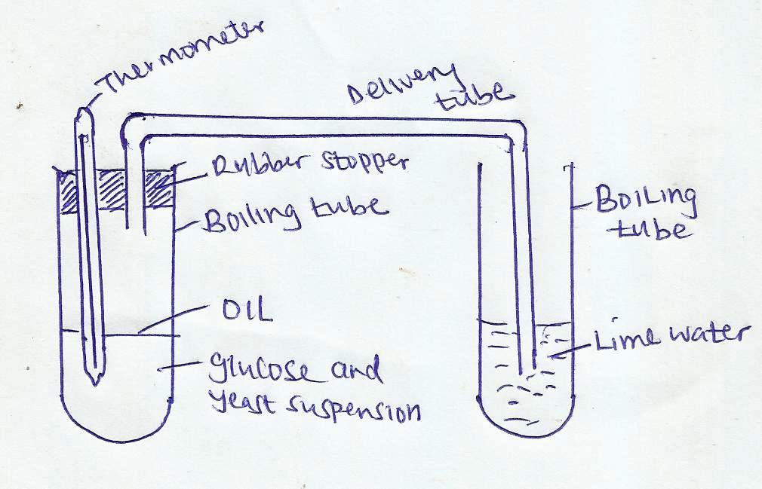

The glucose solution was boiled and cooled before adding yeast. The set up was left in stand for about 30 minutes.
- What changes occurred in the
- lime water (1mk)

- glucose and yeast? (2mks)

- Explain your answer in (a) above (3mks)

- Name the process that was being investigated. (1mk)

- What was the role of oil in the boiling tube? (1mk)

- Suggest control experiments for the above experiment. (2mks)

- Suggest the reason for boiling and cooling glucose before adding yeast. (2mks)

- Distinguish between heterodonts and homodonts. (2mks)

- What is the significance of diastema in herbivorous mammals? (1mk)

- State the role of carnassial teeth in a lion? (1mk)

- An organism was found to have the dental formula:
P

C CC
i
1 0 3 4
M

i
i
1 0 2 4

- Calculate the total number of teeth in the organism (1mk)

- With a reason suggest the mode of feeding of the organism from which dental formula was obtained. (2mks)

- State one adaptation of the animals that uses the mode of feeding above. (1mk)

SECTION C
- Briefly describe the role of Osmosis in living organisms (10 mks)

- Explain 5 factors affecting the rate of breating in human beings. (10 mks)

