Name………………………………………..………….…… Adm.No. ……..……….… Class …….……….

231/3
BIOLOGY
Paper 3
(Practical)
Feb 2012
1 ½ hours
KAHUHO UHURU HIGH SCHOOL
Mid Term Examination 2012 Form Three

INSTRUCTIONS
This paper has ONE section ONLY
Answer ALL the questions in this paper
All answers should be written in the spaces provided on the question paper.
 | Procedure | Observation | Conclusion
Test X | To the food substrate S, add a few drops of Iodine solution shake well and observe the colour changes
Test Y | To the food substrate S, add a few drops  Of Benedict’s solution, heat gently as you shake. Observe and record your observation
Test Z | Put about 2ml of DCPIP solution into a test tube, add a few drops of solution S, Shake and record your observation
Test W | To the food substrate S, add a few drops  of Hcl followed by drops of NaHCO3 until fizzing stops.Add a few drops of Benedicts solution, heat gently as you shake. Observe and record your observation
Questions (50 marks)
- You are provided with solutions labeled S and reagents Benedicts, Iodine, Hcl, NaHCO_{3,} DCPIP and solutions.

- Using the reagents provided, carry out a food test and record the observation and conclusions in the
table below. (8 marks)

- Identify the Tests X,Y,Z and W carried out on S1 and S2 (4 Marks)

X……………………………………………
Y……………………………………………
Z……………………………………………
W…………………………………………...

b) What is the significance of using the following reagents while testing for the above food tests (2 marks)
i) Hydrochloric acid
…………………………………………………………………………………………………………..……………………………………………………………………………………….……………………….
ii) Sodium Hydroxide solution

…………………………………………………………………………………………………………..……………………………………………………………………………………….……………………….
(c) Name two parts in the human body where the food tested with iodine in the table above is digested. (2marks)
…………………………………………………………………………………………………………..……………………………………………………………………………………….……………………….
- The photograph below was taken from an organ of a human body.
- Identify the organ (1 mark)
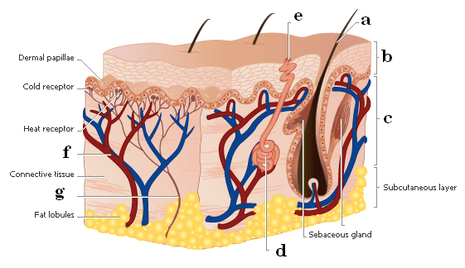

- Identify the parts labeled (7 marks)
a…………………………………………..
b…………………………………………..
c………………………………………….
d……………………………………….…
e………………………………………….
f………………………………………….
g………………………………………….
- State the function of the sebaceous gland (1 mark)
…………………………………………………………………………………………………………..……………………………………………………………………………………….……………………….
- Explain the role of the part labeled f in thermoregulation (2 marks)
…………………………………………………………………………………………………………..……………………………………………………………………………………….……………………….
…………………………………………………………………………………………………………..…
- The subcutaneous layer of animals in temperate areas is thicker than those in tropical areas. explain this with reference to thermoregulation (2 marks)
…………………………………………………………………………………………………………..……………………………………………………………………………………….……………………….
…………………………………………………………………………………………………………..…
- Identify 3 contents produced by the structure labeled d (3 marks)
…………………………………………………………………………………………………………..……………………………………………………………………………………….……………………….
…………………………………………………………………………………………………………..……………………………………………………………………………………….……………………….

3.The photographs below were taken from http://www.ask.com/pictures?qsrc=167&o=13157&l=dis&q use them to answer the questions that follow.
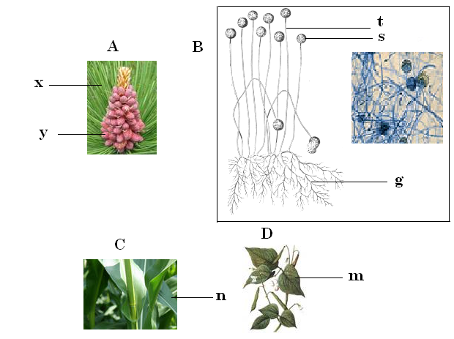
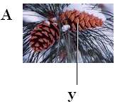

a) Name the division to which photographs labeled A,C and D belong (1 mark)

……………………………………………………………..
- Identify the subdivision to which the following pictures were taken from ( 2 marks)

A……………………………………
C……………………………………

- Name the parts labeled ( 4marks)
y………………………………………
s………………………………………
t………………………………………
g……………………………………...
- State two economic importance of members of kingdom B to man ( 2marks)
…………………………………………………………………………………………………………..……………………………………………………………………………………….……………………….…………………………………………………………………………………………………………..………………………..
- Name the reproductive unit contained in structure labeled s (1 mark)
…………………………………………………………………………………………………………..…
- i) Identify the classes of organisms in photographs C and D (2 marks)
…………………………………………………………………………………………………………………….…………………………………………………………….……………………….………………………………
ii) Give two reasons for your answer in f (i) above (2 marks)
…………………………………………………………………………………………………………..……………………………………………………………………………………….………………………………………
…………………………………………………………………………………………………………..………..
- State one characteristic each that distinguishes the named organisms into their respective groups
A and B ( 2 marks)
…………………………………………………………………………………………………………..……………………………………………………………………………………….……………………….
…………………………………………………………………………………………………………..…
h) Organism in photograph A has characteristics that make it unique from the rest of other subdivision. State
any two of these characteristics ( 2 marks)
…………………………………………………………………………………………………………..……………………………………………………………………………………….……………………….
…………………………………………………………………………………………………………..…

