Name………………………………………..………….…… Adm.No. ……..……….… Class …….……….

231/3
BIOLOGY
Paper 3 (Practical)
Mid Term Exam
Term 3 2011
1 ½ hours

KAHUHO UHURU HIGH SCHOOL
MidTerm Examination 2011 Form Three

INSTRUCTIONS TO CANDIDATES

This paper has ONE section ONLY
Answer ALL the questions in this paper
All answers should be written in the spaces provided on the question paper.

For Official Use Only

SECTION | QUESTION | SCORE
50 Marks | 1
 | 2
 | 3
 | TOTAL

This paper consists of 5 printed pages
Candidates should check the question paper to ensure that all the printed pages are printed as indicated and no questions are missing
- You are provided with solutions labeled T as a food substance. Label our test tubes as X1,X2 and X3 then put 2ml of solution T into 3 test tubes labeled X1, X2 and X3.
a) Using the reagents provided, carry out food tests in X1 to X3, record the procedure, observation and
conclusions in the table below. (9 Marks)
 | Procedure | Observation | Conclusion
X1
Iodine Test
X2
Benedicts
Test
X3
Test for proteins

b) i) What role does food substances tested in X1 and X2 play in human nutrition (1 mk)

…………………………………………………………………………………………..
ii) Explain your answer in b) i) above (2mk)

…………………………………………………………………………………………..
c) Of the three food substances tested, which may be found abundant in a patient suffering from
Diabetes mellitus (1mk)

…………………………………………………………………………………………..
d) Name any two sources of the food tested in X1 above (2mks)

…………………………………………………………………………………………..
…………………………………………………………………………………………..
e) In what circumstance does the food tested in X3 oxidized to supply energy (1mk)

…………………………………………………………………………………………..
2. The photograph shown below is a representative of the human circulatory system. Use it to answer the questions that follow.
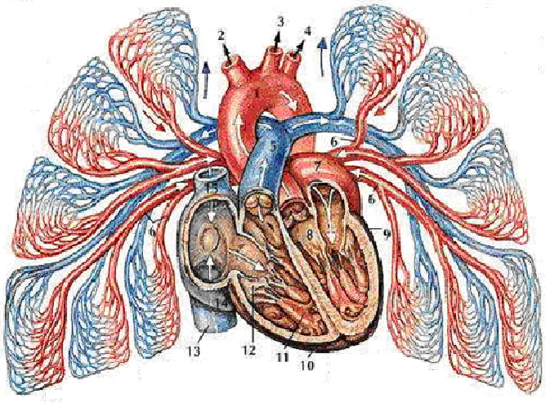

a) Identify the parts labeled (5mks)
1. …………………………….
5. …………………………….
9. …………………………….
10. …………………………….
12. …………………………….
b) Explain the significance of having the left ventricle being thick and muscular than the right ventricle (2mks)
…………………………………………………………………………………………..
…………………………………………………………………………………………..
c) State two adaptations of the parts labeled 13 and 15 (2mks)
…………………………………………………………………………………………..
…………………………………………………………………………………………..
d) State the function of the part labeled 12 (1mk)
…………………………………………………………………………………………..
e) What name is given to the movement of blood from part 13/15 through part5 to the lungs then through
part 7 and into the heart (1mk)
…………………………………………………………………………………………..
f) Identify the disorders that may come as a result of : (2mks)
a) Hardening of the arteries due to calcium deposits
…………………………………………………………………………………………..
b) Large amounts of cholesterol in blood
…………………………………………………………………………………………..
g) Which substances are found in part 1 and not in the glomerular filtrate (3mks)
…………………………………………………………………………………………..
…………………………………………………………………………………………..
…………………………………………………………………………………………..
h) The muscles in the organ above are said to be myogenic. Explain (1mk)
…………………………………………………………………………………………..
3.The photograph below was obtained from a plant’s reproductive organ. Use it to answer the questions that follow
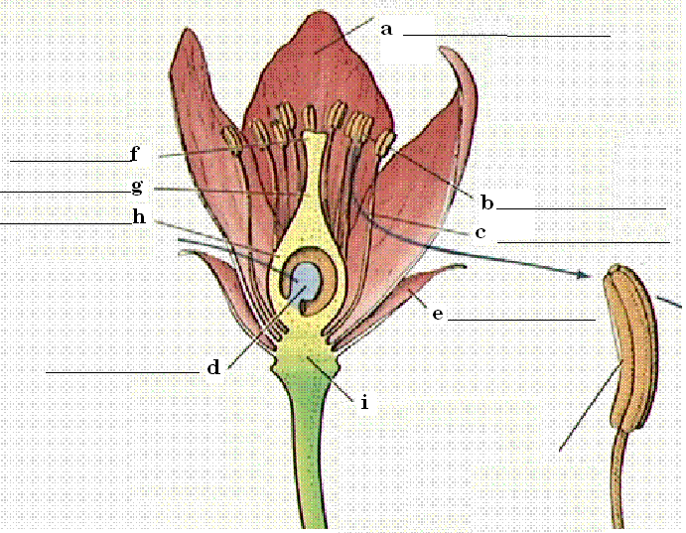
x
a) On the photograph, identify the parts labeled a to h (8mks)

b) State how the parts indicated below enable the organ to adapt itself to its functions. (2mks)

a…………………………………………………………………………………………………………
g …………………………………………………………………………………………………………
c) The part labeled x contains reproductive cells
i) Identify the reproductive cells……………………………………………………………(2mks)
ii) Explain briefly how the cells you identified above are involved in double fertilization (2mks)
…………………………………………………………………………………………..
…………………………………………………………………………………………..
…………………………………………………………………………………………..
d) What happens to the following parts after fertilization (3mks)
a…………………………………………………………………………………………..
d…………………………………………………………………………………………..
h…………………………………………………………………………………………..

good luck
Department of Biological sciences

