Name………………………………………..………….…… Adm.No. ……..……….… Class …….……….

231/3
BIOLOGY
Paper 3
(Practical)
Sept 2015
1 ½ hours
KAHUHO UHURU HIGH SCHOOL
GATUNDU FORM 4 EVALUATION EXAM

INSTRUCTIONS
Answer ALL the questions in this paper
All answers should be written in the spaces provided on the question paper.

Questions (40 marks)
- You have been provided with specimen K.use it to answer the questions that follow
(i) What part of plant is specimen K? (1mark)

(ii) Give a reason for your answer in 3 (i) above (1mark)

(iii) Make a cross section of specimen K. Draw and label the parts. (3marks)

(iv) State the type of placentation in specimen K. (1mark)

(v) Name the agent of dispersal of specimen K and give a reason for your answer. (2marks)

(vi) Squeeze the juice from specimen K. Using the reagents provided, carry out food tests. (6marks)

 | Procedure | Observation | Conclusion

2.You are provided with photographs A and B.use them to answer the questions that follow
A

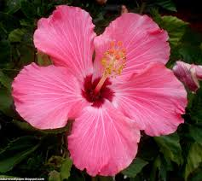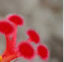
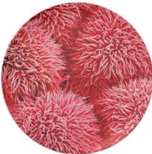

B

a) Name the sub-division of the plant from which the photo was taken. (1 mark)

b) Using observable features on the photograph give reasons for your answer in (a) above. (2 marks)

c) Name the agent of pollination for the flower in the photograph (1 mark)

d) State three observations on the photograph that supports your answer in (c) above. (3 marks)

e) Name the class of the plant from which the photo was taken. (1 mark)

f) Using observable features on the photograph, give three reasons for your answer in (e) above. (3 marks)

g) Give two adaptations of the part labeled B to its pollination function. (2 marks)

- You are provided with photographs X, Y and Z.use them to answer the questions that follow

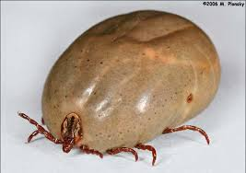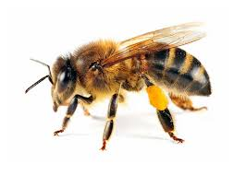
Y
X
Z
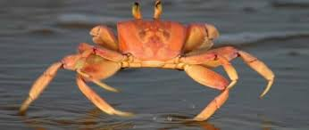

(i) To which phylum does organisms x,y and z belong to. (1 mark)

(ii) Name the classes to which X, Y and Z belongs to. (3 marks)

(iii) Give two important economic roles of specimen Y. (2 marks)
(iv) Give three harmful effects of specimen X to animals. (3 marks)
(v) With reasons identify two modes of locomotion of specimen Y . (4 marks)

