Name………………………………………..………….…… Adm.No. ……..……….… Class …….……….

231/3
BIOLOGY
Paper 3
(Practical)
June 2014
1 ½ hours
KAHUHO UHURU HIGH SCHOOL
Mid Term Examination 2014 Form Three

INSTRUCTIONS
This paper has ONE section ONLY
Answer ALL the questions in this paper
All answers should be written in the spaces provided on the question paper.

Questions (50 marks)
- You are provided with solutions labeled S, reagents Benedicts, Iodine, Hcl, NaHCO_{3,} DCPIP solutions.

- Using solution S and reagents provided, carry out a food test and record the observation and conclusions in the table below. (9 marks)

 | Procedure | Observation | Conclusion
Iodine Test

Non Reducing Sugar

DCPIP Test

- Identify the functions of the food you tested under the following as utilized by human beings (2marks)

DCPIP ………………………………………………………………….…………………………….……
Non Reducing Sugar…………………………………………………………….……………………………
b) What is the significance of using the following reagents while testing for the above food tests(2 marks)
i) Hydrochloric acid
…………………………………………………………………………………………………………..……………………………………………………………………………………….……………………….
ii) Sodium Hydrogen carbonate solution
…………………………………………………………………………………………………………..……………………………………………………………………………………….……………………….
(c) Name two areas in the human body where the food tested with iodine in the table above is digested. (2marks)
…………………………………………………………………………………………………………..……………………………………………………………………………………….……………………….
- The diagram below was taken from a unit of an organ in the human body.
- Identify the structure…………………………………………….. (1 mark)
b
e
f
a
d
c
g
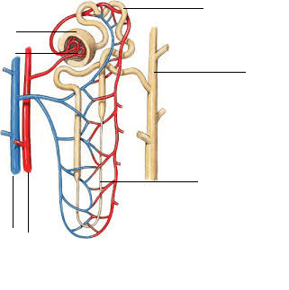

- Identify the parts labeled (6 marks)
a…………………………………………..
b…………………………………………..
c………………………………………….
d……………………………………….…
e………………………………………….
f………………………………………….
- State the function of the part labelled g and b (2 marks)
g…………………………………………………………………………………………………..…
b…………………………………………………………………………….……………………….
- Explain the role of the part labeled g in osmomoregulation (2 marks)
…………………………………………………………………………………………………………..……………………………………………………………………………………….……………………….
…………………………………………………………………………………………………………..…
- The part labelled d in desert animals is longer than that of animals in aquatic areas. Explain this with reference to osmoregulation (2 marks)
…………………………………………………………………………………………………………..……………………………………………………………………………………….……………………….
…………………………………………………………………………………………………………..…
- Identify 3 contents that enter part labelled g but are not found in part labelled b (3 marks)
…………………………………………………………………………………………………………..……………………………………………………………………………………….……………………….
…………………………………………………………………………………………………………..…
3.The photographs below were as samples from the Kenya wildlife service. Use them to answer the questions that follow.
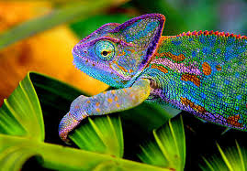
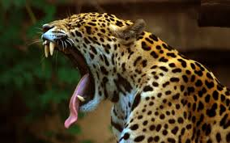
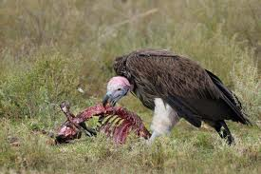

U V W
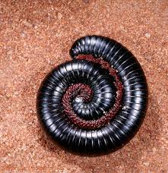
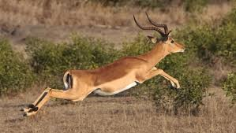
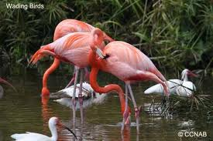

X Y Z

a) Name the classes to which photographs labeled U,V, X and Z belong (3 marks)
U…………………..…………………
V………………….………………….
X……………………………………..
Z……………………………………..
- Among the photographs, Identify; ( 3 marks)

Predator……………………………………
Prey………………………………………..
Scavenger………………………………….
- From observable features only, state one adaptation each that enables the following organisms to survive in their habitats ( 4marks)
U………………………………………………………………………………………………………
V………………………………………………………………………………………………………
Y………………………………………………………………………………………………………
Z……………………………………………………………………….……………………………...
- State two effects that water pollution will have to the animal labeled X (2marks)
…………………………………………………………………………………………………………..……………………………………………………………………………………….……………………….…………………………………………………………………………………………………………..………………………..
- Starting with grass, construct a food chain that involves organisms V,W and Y (Use letters only)(4 marks)

- What would be the effect of the following to the food chain you constructed? (2 marks)
- prolonged drought
…………………………………………………………………………………………………………………….…………………………………………………………….……………………….…
- Removal of Y
…………………………………………………………………………………………………………………….…………………………………………………………….……………………….…
- i) Photograph Z indicates a type of a defensive behaviour, Name the type of behaviour (1 mark)
…………………………………………………………………………………………………………………….…………………………………………………………….……………………….………………………………...…

The end

