231/3
BIOLOGY
Paper 3
(Practical) Marking scheme
June 2014
1 ½ hours
KAHUHO UHURU HIGH SCHOOL
Mid Term Examination 2014 Form Three

INSTRUCTIONS
This paper has ONE section ONLY
Answer ALL the questions in this paper
All answers should be written in the spaces provided on the question paper.

Questions (50 marks)
- You are provided with solutions labeled S, reagents Benedicts, Iodine, Hcl, NaHCO_{3,} DCPIP solutions.

- Using solution S and reagents provided, carry out a food test and record the observation and conclusions in the table below. (9 marks)

 | Procedure | Observation | Conclusion
Iodine Test | Put 2ml of solution S in a test tube, add iodine solution and shake. Record your observation | The colour of iodine is retained/No noticeable colour change | Starch absent
Non Reducing Sugar | Put 2ml of solution S in a test tube, add a few drops of Hydrochloric acid and heat gently.Cool over running tap water, add a few drops of sodium hydrogen carbonate untill fizzing stops, add an equal amt of benedicts’ solution and heat gently Record your observation | The solution retains the colour of benedicts solution/No noticeable colour change | Non reducing sugars are absent
DCPIP Test | Put 2ml of solution DCPIP solution in a test tube, add an equal amount of Solution S as you shake. Record your observation | The Solution S contained in the test tube is decolourised | Ascorbic acid/Vitamin C present
NB: Reject if symbols only are used, order must be correct, Benedicts’ (with apostrophe), If procedure is
wrong, reject observation and conclusion
- Identify the functions of the food you tested under the following as utilized by human beings (2marks)
DCPIP Vitamin C’s necessary for healing wounds, in addition to mending and preservation of bones, cartilage, as well as teeth.
Non Reducing Sugar It is hydrolyzed to provide energy
b) What is the significance of using the following reagents while testing for the above food tests (2 marks)
i) Hydrochloric acid
Hydrolyses/ breaks down the non reducing sugar to a reducing sugar

ii) Sodium Hydrogen carbonate solution
It neutralizes the Hydrochloric acid that was used earlier during hydrolysis
(c) Name two areas in the human body where the food tested with iodine in the table above is digested. (2marks)
-Mouth
-Duodenum
- The diagram below was taken from a unit of an organ in the human body.
- Identify the structure…Kidney Nephron (1 mark)
b
e
f
a
d
c
g
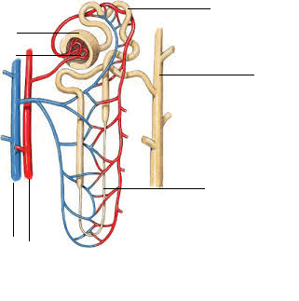

- Identify the parts labeled (6 marks)
a…Bowmans’ capsule
b…Proximal convulated tubule
c…Collecting duct/tubule
d…Ascending loop of henle
e…Renal Vein
f…Renal artery

- State the function of the part labelled g and b (2 marks)
g…Ultrafiltration; Separation of small blood molecules from large ones
b…Reabsoption of important substances such as glucose
- Explain the role of the part labeled g in osmoregulation (2 marks)
During ultrafiltration, Large molecules such as blood cells are separated from small molecules which eventually form glomerular filtrate; This filtrate have excess water and mineral ions which are later excreted to balance the body’s osmotic pressure
- The part labelled d in desert animals is longer than that of animals in aquatic areas. Explain this with reference to osmoregulation (2 marks)
In desert animals, the loop of henle is long to increase the surface area for reabsorption of water;
aquatic animals do not require water conservation.
- Identify 3 contents that enter part labelled g but are not found in part labelled b (3 marks)
-Blood cells
-Dissolved proteins
-Amino acids
3.The photographs below were as samples from the Kenya wildlife service. Use them to answer the questions that follow.
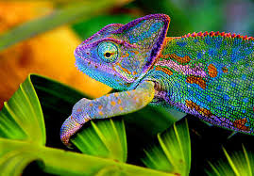
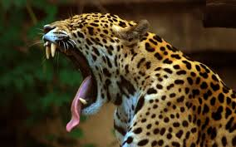
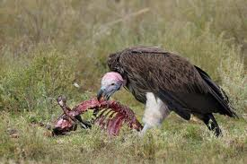

U V W
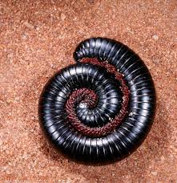
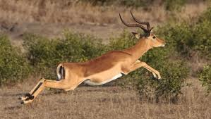
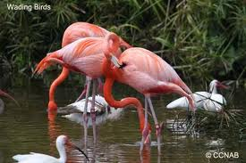

X Y Z

a) Name the classes to which photographs labeled U,V, X and Z belong (3 marks)
U…Amphibia
V…Mammalia
X…Aves
Z…Diplopoda

- Among the photographs, Identify; ( 3 marks)

Predator…V,U
Prey…… U, Y, Z
Scavenger…W
- From observable features only, state one adaptation each that enables the following organisms to survive in their habitats ( 4marks)
U…Camouflage/Colour blends with the background
V… Camouflage; Presence of Canine teeth for tearing fleshy
Y…Streamlined body for fast movement; Camouflage; good eyesight
Z…Mimicry/ pretends to be dead to escape predation
- State two effects that water pollution will have to the animal labeled X (2marks)
-Oil clogs the wings preventing movement/flight
-Oil interferes with gaseous exchange
-Heavy metals accumulate to high levels leading to respiratory diseases

- Starting with grass, construct a food chain that involves organisms V,W and Y (Use letters only)(4 marks)
√ √ √
Grass Y V W ( The arrow points to eater)

( Correct order 1mk)-√
- What would be the effect of the following to the food chain you constructed? (2 marks)
- prolonged drought
Leads to decrease in primary consumers(Y) and consequently secondary(V) and tertiary consumers(W)
- Removal of Y
Leads to increase in primary producers/grass, decrease in secondary and tertiary consumers (V and W)
- i) Photograph Z indicates a type of a defensive behaviour, Name the type of behaviour (1 mark)
Mimicry

The end

