Name: …………………………………………………………… Adm No ……..…...................................
Date: …………………………………………………………… Class ………………………………….
231/3
BIOLOGY
TERM 3 2013
2 HOURS
RUNGIRI HIGH SCHOOL
Form Two End Year Examination.

Biology
Form Three
2 Hours
Term 3 2013

INSTRUCTIONS TO STUDENTS:
- Write your name, admission number and class in the spaces provided.
- Write the date of examination in the space provided above.
- Answer all the questions in the question paper in the spaces provided after each question.
- This question paper consist of 7 printed pages. Each student should ensure that all the pages are printed as indicated and that no pages are missing.

For Examiner’s Use Only
Question | Max Score | Student’s Score
1 | 15
2 | 11
3 | 14
Total
40

- The diagram below shows a dissection of the ventral region of a small mammal. Study the photograph
and answer the questions that follow.
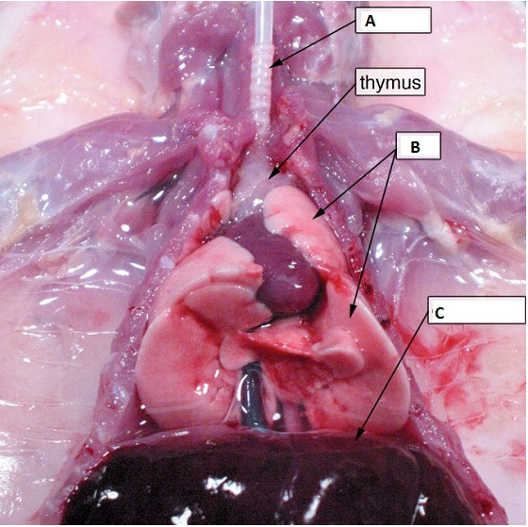

(a). Name two body systems represented in the photograph. (2 marks)
……………………………………………………………………………………………………………………………………………………...…………………………………………………………………………
(b). Identify each of the parts labeled A and C. (2 marks)
……………………………………………………………………………………………………………………………………………………...…………………………………………………………………………
(c) (i). State the role of part labeled A. (1 mark)
…………………………………………………………………………………………………………………………………………………………………………………………………………………………
(ii). State two adaptations of the part named in (c) (i) above. (2 marks)
…………………………………………………………………………………………………………………………………………………………………………………………………………………………………………………………………………………………………………………………………………………………………………………………………………………………….………………………
(d). State three adaptations of the part labeled B. (3 marks)
…………………………………………………………………………………………………………………………………………………………………………………………………………………………………………………………………………………………………………………………………………………………………………………………………………………………………………………………………………………………………………………………………………………………………………...……
(e). Explain the role of the part labeled C. (3 marks)
…………………………………………………………………………………………………………………………………………………………………………………………………………………………………………………………………………………………………..……………………………………………
(f). Name an organism that may infect the part labeled B and identify the disease it causes. (2 marks)

…………………………………………………………………………………………………………………………………………………………………………………………………………………………………………………………………………………………………………………………………..………….…

- The diagram below shows some types of fruits.
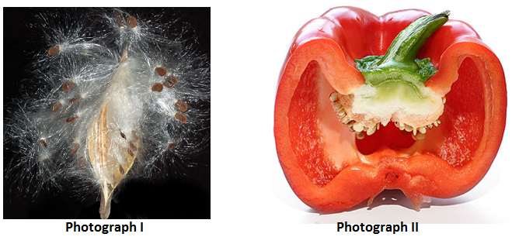
(a) (i). Name the type of fruit in photograph I (1 mark)
………………………………………………………………………………………………………………………………………………………………………………………………………………………………………………
(ii). Give a reason for your answer. (1 mark)
………………………………………………………………………………………………………………………………………………………………………………………………………………………………………………

(iii). State the mode of dispersal of the fruit named in (a) (i) above. Explain (2 marks)
…………………………………………………………………………………………………………………………………………………………………………………………………………………………....…………………
(b) (i). Name the type of fruit in photograph II. (1 mark)
………………………………………………………………………………………………………………………………………………………………………………………………………………………………………………
(ii). Give a reason for your answer. (1 mark)
………………………………………………………………………………………………………………………………………………………………………………………………………………………………………………
(iii). What type of placentation does the fruit have? (1 mark)
………………………………………………………………………………………………………………………………………………………………………………………………………………………………………………
(iv). Explain two adaptations of the fruit to its mode of dispersal. (2 marks)
………………………………………………………………………………………………………………………………………………………………………………………………………………………………………………
………………………………………………………………………………………………………………………
(c). On the diagram in photograph II label the placenta and the endocarp. (2 marks)

3. You are provided with a specimen labeled T. Study it and answer the questions that follow. Using a knife or
scalpel make a transverse section of the specimen.
(a) (i). What plant part is specimen T? (1 mark)
………………………………………………………………………………………………………………………………………………………………………………………………………………………………………………
(ii). Give a reason for your answer. (1 mark)
………………………………………………………………………………………………………………………………………………………………………………………………………………………………………………

(b). Squeeze the juice from specimen T into the 100ml beaker provided. Using the reagents provided carry out food tests on the juice. (12 marks)

Food substance | Procedure | Observations | Conclusions

