KAHUHO UHURU HIGH SCHOOL
BIOLOGY END OF TERM 1 2011 EXAMS

BIOLOGY PP 3
TIME 1 ½ Hrs

NAME…………………………………………..CLASS…………ADM NUMBER……………

Instructions

- Answer all questions
- You are required to spend the first 10 minutes of the 1 ½ hours allowed for this paper reading the whole carefully before commencing your work.
- Answers must be written in the spaces provided in the questions paper
- Additional pages must not be inserted.
- Candidates may be penalized for recording irrelevant information and incorrect spelling for technical terms.

1. You are provided with specimen labeled A, B and C which is placed in a container of clean water Remove the specimen from water and examine it.

a) Using observable features only classify the specimen into the following taxa.

- Specimen A

Class: (1mk)
…………………………………………
Reasons:
………………………………………………………………………………………… (2 mks) ……………………………………………………………………………………………………………………
……………………………………………………………………………………………………………………

- Specimen B

Class (1mk)
…………………………………………………….
Reasons:
……………………………………………………………………………………………………………………
……………………………………………………………………………………………………………………………………………………………………………………………………………………………… (2mks)

- Specimen C

Kingdom (1mk)
…………………………………………
Reasons:
……………………………………………………………………………………………………………………
…………………………………………………………………………………………………………………………………………………………………………………………………………………………………(2mks)

Economic importance to man (2mks)
………………………………………………………………………………………………………………………………………………………………………………………………………………………………………………………………………………………………………………………………………………………………
b) Using external features only, state how specimen A is adapted to its functions (3mks)
………………………………………………………………………………………………………………………………………………………………………………………………………………………………………………………………………………………………………………………………………………………………
…………………………………………………………………………………………………………………………………………………………………………………………………………………………………………

2. You are provided with solution labeled P and S.. Using the reagents Provided:-
a) Carry outs tests to determine the food substance (s) in P and S . (12 mks)

Food substances being tested for | Procedure | Observations | Conclusions
STARCH
( Using P)
REDUCING SUGARS
( Using P)
NON REDUCING SUGARS
( Using P)

VITAMINS
( Using S)

b) Give a reason why Hcl was used in one of the tests (1mk)
……………………………………………………………………………………………………………………
…………………………………………………………………………………………………………………………………………………………………………………………………………………………………………

c) What is the nutritional importance of the food substance tested with DCPIP solution (1mk)
……………………………………………………………………………………………………………………
…………………………………………………………………………………………………………………………………………………………………………………………………………………………………………

3.The pictures below were taken from the human respiratory system. Use it to answer the questions that follow
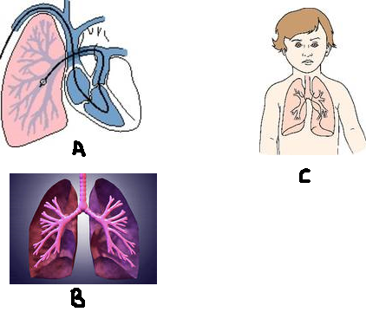
k

P

a)Using arrows, indicate on the diagrams (3mks)
i) Trachea as X
ii)Bronchioles as Y
iii)Position of the diaphragm as Z

b)Identify the blood vessel marked K (1mk)
…………………………………………………………………………………………………………………………………………………………………………………………………………………………………………
c) State two adaptations of the part lebbled P to its functions (2mks)
……………………………………………………………………………………………………………………
…………………………………………………………………………………………………………………………………………………………………………………………………………………………………………
d) State any three characteristics of the structure labeled B to gaseous exchange (3mks)
……………………………………………………………………………………………………………………
…………………………………………………………………………………………………………………………………………………………………………………………………………………………………………
e) State three diseases that affect the above organs due to (3mks)
i) Presence of pollen grains, fur, or dust……………………………………………………………
ii) Excessive smoking ……………………………………………………………
iii) Micobacterium tuberculosis ……………………………………………………………

Good luck

