KAHUHO UHURU HIGH SCHOOL
END OF TERM 3 EXAMINATION
BIOLOGY
231 / 3 Name…….………………………………………………………….
PAPER 3 PRACTICAL Class…………………………….Adm No……………….Roll……
TIME 1 ¾ HRS

INTRUCTIONS:

- Answer ALL the questions in the spaces provided.
- You are required to spend the first 10 minutes of the 1 ¾ hours allowed for this paper . Candidates may be penalized for recording irrelevant information and incorrect spelling of technical terms.

- You are provided with the following:
- Solution K
- Dilute hydrochloric acid L₆
- Iodine solution labelled L₁
- Benedicts solution labelled L₂
- 1% copper sulphate solution labelled L₃
- 0.1% sodium hydroxide labelled L₄
- sodium hydrogen carbonate L₅
- Distilled water,
- Mortar and pestle.
- 4 Test tubes
- A means of heating.

  - Using the apparatus provided extract a solution from K. test the extract using the reagents provided and tabulate your results as follows: - (12 mks)
TEST | PROCEDURE | OBSERVATION | DEDUCTION
Iodine

Benedict
Non-reducing sugar

Proteins

  - Name any other food substance NOT tested above but of great value in nutrition (1mk)

……………………………………………………

  - Which nutritional value does the food mentioned in (b) above provide (1mk)

……………………………………………………….........................................................

  - Of the food substrates tested above, which one produces the greatest kilo joules per gramme
(1mk)
…………………………………………………….

2. The photographs below were obtained in different habitats of Kenya. Study them and answer the questions that follow.
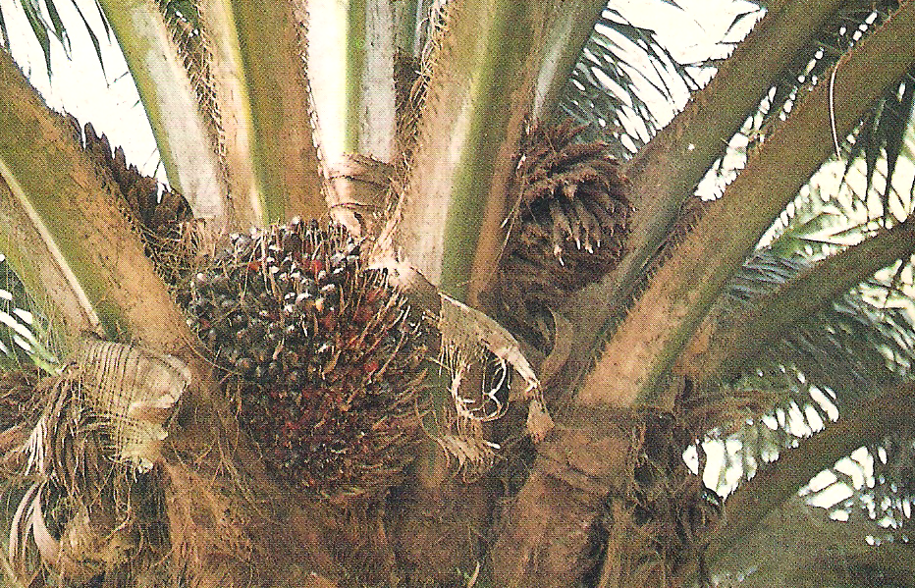
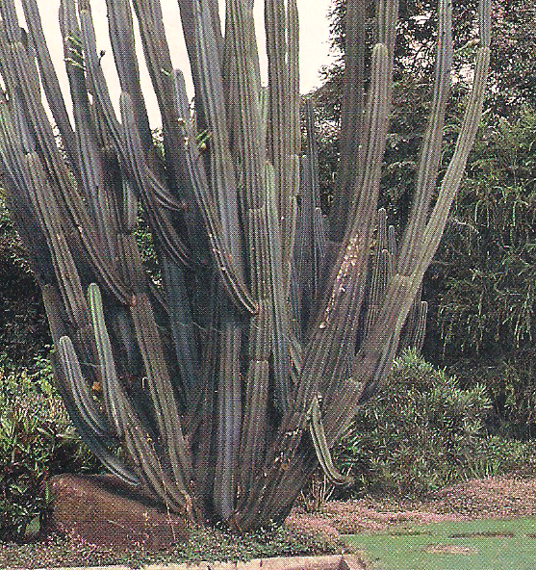
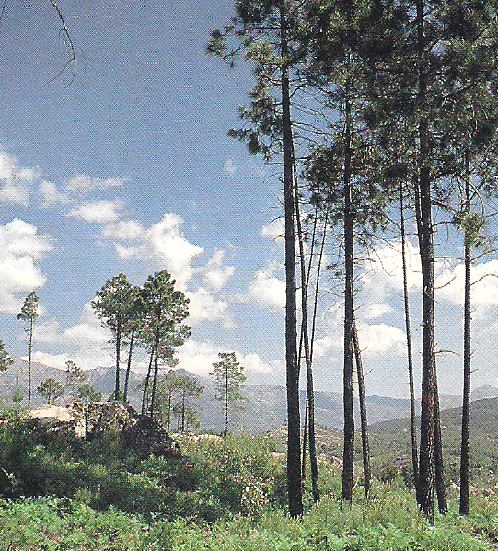
Fig B
Fig A
Fig C
- Identify the habitats of plants (3mks)

A………………………
B………………………
C………………………
b)On fig A, use an arrow to indicate the reproductive organ. (1mk)

c)State the type of growth that takes place in plant in fig C and not in Monocotyledonous plants (1mk)

………………………………..

d)State 3 adaptations of plants in fig B and C that enable them to survive in their habitats (6mks)
B ……………………………………………………………………………………………..
……………………………………………………………………………………………..
…………………………………………………………………………………………….
…………………………………………………………………………………………….
…………………………………………………………………………………………….
…………………………………………………………………………………………….
…………………………………………………………………………………………….

C ……………………………………………………………………………………………..
……………………………………………………………………………………………..
…………………………………………………………………………………………….
…………………………………………………………………………………………….
…………………………………………………………………………………………….
…………………………………………………………………………………………….
…………………………………………………………………………………………….
e) State the economic importance of the three types of plants to man (3mks)
A …………………………………………………………………………………………
…………………………………………………………………………………………….
…………………………………………………………………………………………….

B …………………………………………………………………………………………
…………………………………………………………………………………………….
…………………………………………………………………………………………….

C …………………………………………………………………………………………
…………………………………………………………………………………………….
…………………………………………………………………………………………….
- The photographs below are blood vessels taken from the body of a healthy human being. Use it to answer the questions that follow.
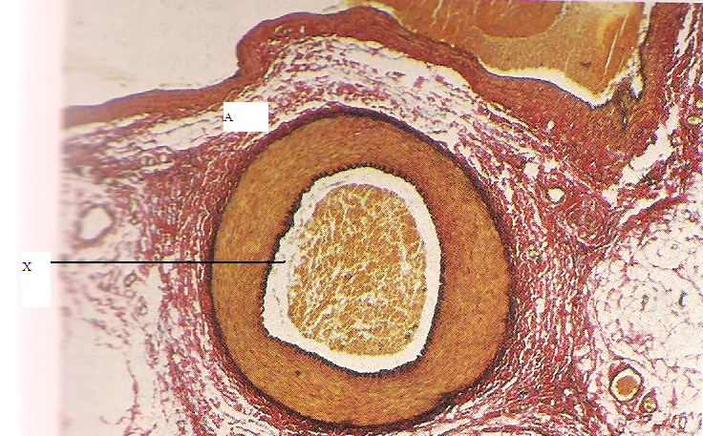
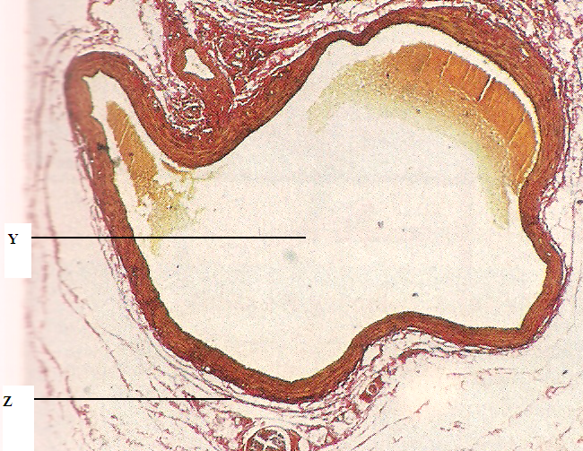
Fig 1
Fig 2

  - Identify vessels 1 and 2 (2mks)
1……………………………………

2……………………………………

  - Give two reasons for your answers in (a) above (2 mks)
………………………………………………………………………………………..
………………………………………………………………………………………..
………………………………………………………………………………………..
c)Identify the parts labeled (3mks)

X………………………………………..
Y……………………………………….
Z……………………………………….
  - State three structural differences between vessel 1 and 2 (3mks)
………………………………………………………………………………………..
………………………………………………………………………………………..
………………………………………………………………………………………..
………………………………………………………………………………………..
………………………………………………………………………………………..
………………………………………………………………………………………..

  - Which defect will occur as a result of vessel 2 becoming swollen and flabby due to failure of the valves to function properly? (1mk)
………………………………………………………………………………………..
………………………………………………………………………………………..
………………………………………………………………………………………..
………………………………………………………………………………………..

Best wishes

