KAHUHO UHURU HIGH SCHOOL
TERM 3 2014 MID TERM 3 EXAM

BIOLOGY 231 / 3 Name…….………………………………………………………….
PAPER 3 PRACTICAL Class…………………………….Adm No……………….Roll……
TIME 1 ½ HRS
INTRUCTIONS:

- Answer ALL the questions in the spaces provided.
- You are required to spend the first 10 minutes of the 1 ¾ hours allowed for this paper . Candidates may be penalized for recording irrelevant information and incorrect spelling of technical terms.

- You are provided with the following:
- Specimen K
- Dilute hydrochloric acid
- Iodine solution
- Benedicts solution
- 1% copper sulphate solution
- 0.1% sodium hydroxide
- sodium hydrogen carbonate
- Distilled water,
- 3 Test tubes
- Water bath

  - Extract a solution from K by crushing and adding some water to make a test tube full. test the extract using the reagents provided and tabulate your results as follows: - (12 mks)

TEST | PROCEDURE | OBSERVATION | DEDUCTION
  - Name any other food substance NOT tested above but of great value in nutrition (1mk)

……………………………………………………
  - Which nutritional value does the food mentioned in (b) above provide (1mk)

……………………………………………………….........................................................

  - Of the food substrates tested above, which one produces the greatest kilo joules per gramme
(1mk)
…………………………………………………….

- The photographs below are samples taken from plant reproduction. Study them and answer the questions that follow.

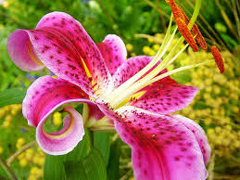
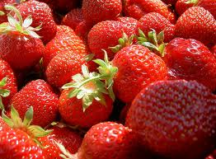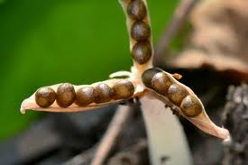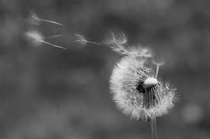
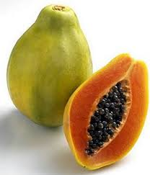
Fig C
Fig A
Fig D
Fig B

z

x

y

Fig E

- Identify the parts labelled (3marks)

X………………………………..………………
Y………………………………………………..
Z………………………………………………..

- Name the type of petals in the organ found in fig A (1mark)
………………………………………………………………………………………..
………………………………………………………………………………………..

- Giving a reason, identify the type of pollination in fig A (2marks)
………………………………………………………………………………………..
………………………………………………………………………………………..

- Identify the types of placentation found in fruits in fig B and D (2marks)
B………………………………………………………………………………………..
………………………………………………………………………………………..
D………………………………………………………………………………………..
………………………………………………………………………………………..

- i)How can one classify the fruits in fig C and D (2marks)
………………………………………………………………………………………..
………………………………………………………………………………………..

ii) Give reasons for your answer in d) i) above
………………………………………………………………………………………..…
………………………………………………………………………..…………………
………………………………………………………..…………………………………

- Giving reasons,identify the agents of seed dispersal in fig D and E (4marks)

D………………………………………………………………………………………..
…………………………………………………………………………………………..
E……………………………………………………………………………….………..
…………………………………………………………………………………………..

- The photographs below are blood vessels taken from the body of a healthy human being. Use it to answer the questions that follow.
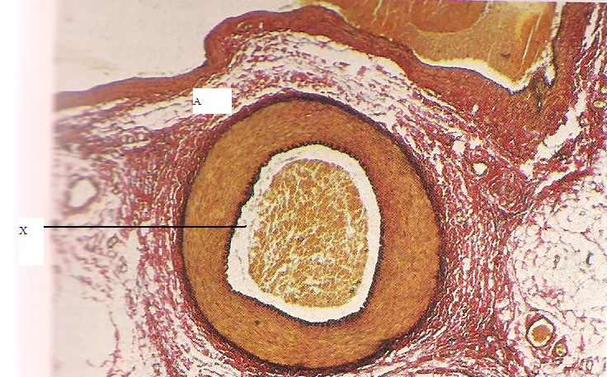
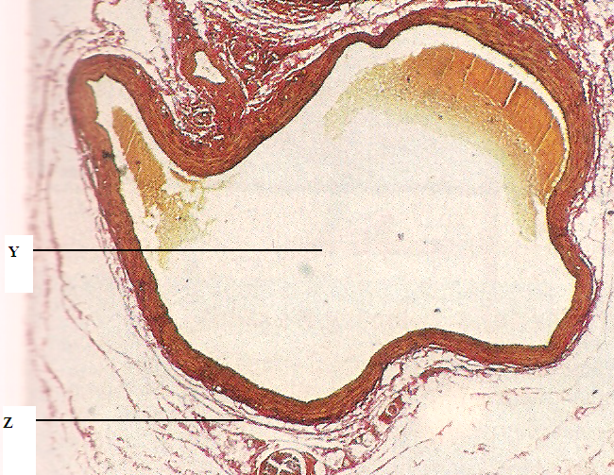
Fig 1
Fig 2

  - Identify vessels 1 and 2 (2mks)
1……………………………………

2……………………………………

  - Give two reasons for your answers in (a) above (2 mks)
………………………………………………………………………………………..
………………………………………………………………………………………..
………………………………………………………………………………………..
c)Identify the parts labeled (3mks)

X………………………………………..
Y……………………………………….
Z……………………………………….
  - State three structural differences between vessel 1 and 2 (3mks)
………………………………………………………………………………………..
………………………………………………………………………………………..
………………………………………………………………………………………..
………………………………………………………………………………………..
………………………………………………………………………………………..
………………………………………………………………………………………..
  - Which defect will occur as a result of vessel 2 becoming swollen and flabby due to failure of the valves to function properly? (1mk)
………………………………………………………………………………………..
………………………………………………………………………………………..
………………………………………………………………………………………..
………………………………………………………………………………………..

