Name…………………………………………………… Adm Number…………….……
Class……………………. Date……………………………

BIOLOGY
PAPER 3 (PRACTICAL)
PRE-MOCK EXAM
JAN/MARCH 2014
1 ³/₄ HOURS

RUNGIRI HIGH SCHOOL
Kenya Certificate of Secondary Education

Biology
Paper 3 (Practical)
1 ³/₄ hours

Instructions to candidates.
- Write your name and index number in the spaces provided above.
- Sign and write the date of examination in the spaces provided above
- Answer ALL the questions in the spaces provided
- You are supposed to use the first 15 minutes of the 1 ³/₄ hours allowed for this paper going through the exam paper carefully before commencing with writing.
- This paper consists of 5 printed pages.
- Candidates should check the question paper to ascertain that all the pages are printed as indicated and that no questions are missing.
- Wrong spellings of scientific terms may be penalized.

For Examiner’s use only
Question | Maximum Score | Candidate's Score
1 | 12
2 | 09
3 | 19
TOTAL | 40
© RHS. SCIENCE DEPT. 2014
Kenya Certificate of Secondary Education, 2014
BIOLOGY
Paper 3
- You are provided with solid labeled X. Take the entire solid and dissolve it in the 50cm³ of distilled water provided. Divide the solution into three test tubes. Use the reagents provided to test for the food substance present in solid X. (12 marks)

FOOD TEST | PROCEDURE | OBSERVATION | CONCLUSION

- You are provided with a photograph of specimen M and a magnified version of the specimen from the underside. Use it to answer the questions that follow.

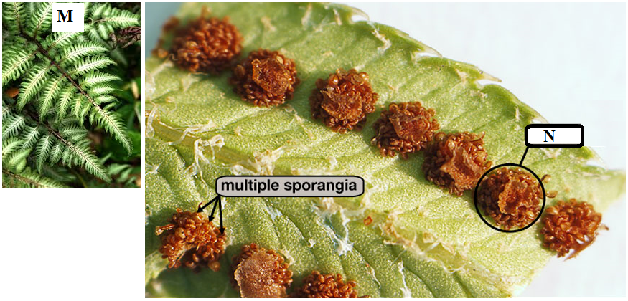

- (i) Name the plant organ represented by the photograph. (1 mark)
……………………………………………………………………………………………………… (ii) Name part label N. (1 mark)
………………………………………………………………………………………………………
(iii) State the function of part labeled N. (1 mark)
………………………………………………………………………………………………………………………………………………………………………………………………………………
(b) Using observable features give two reasons to explain the Division to which the specimen belongs. (3 marks)
Division
………………………………………………………………………………………………………
Reasons
………………………………………………………………………………………………………………………………………………………………………………………………………………………………………………………………………………………………………………………………………………………………………………………………………………………………
(c) (i) Which generation of the plant is represented by the photograph? Give a reason. (2 marks)
………………………………………………………………………………………………………………………………………………………………………………………………………………………………………………………………………………………………………………………
(ii) Give the name of the structure that produces sperm for this plant. (1 mark)
………………………………………………………………………………………………............

- You are provided with a photograph of an organ system of a mammal.

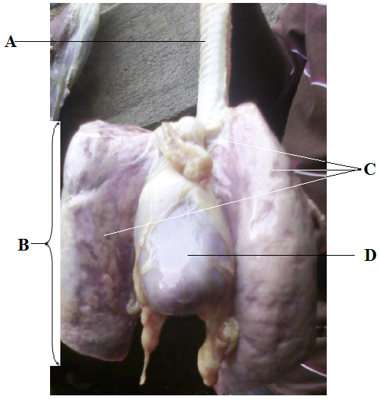
(a) (i) Name the organ system represented by the photograph. (1 mark)
……………………………………………………………………………………………………

(ii) State the function of the organ system named in 3(a) above. (1 mark)
………………………………………………………………………………………………………………………………………………………………………………………………………………
(b) Name the parts labeled A, B and C (3 marks)
A ……………………………………………………………………………….
B ……………………………………………………………………………….
C ……………………………………………………………………………….
(c) (i) What is the function of part labeled A. (1 mark)
………………………………………………………………………………………………………………………………………………………………………………………………………………
(ii) State 4 ways in which structure labeled D is adapted to its function. (4 marks)
………………………………………………………………………………………………………………………………………………………………………………………………………………………………………………………………………………………………………………………………………………………………………………………………………………………………
(d) (i) State three features that adapt structure B to its function. (3 marks)
………………………………………………………………………………………………………………………………………………………………………………………………………………………………………………………………………………………………………………………………………………………………………………………………………………………………
(ii) Describe how air moves from the atmosphere until it gets into structure B and finally into
the blood. (6 marks)
………………………………………………………………………………………………………………………………………………………………………………………………………………………………………………………………………………………………………………………………………………………………………………………………………………………………
………………………………………………………………………………………………………………………………………………………………………………………………………………

This Is The Last Printed Page.

