Name……………………………………………………………………… Adm Number…….……
Class………….
Score

BIOLOGY
PAPER 3 (PRACTICAL)
MID TERM EXAM
FEB 2015
1 ¹/₂ HRS

KAHUHO UHURU HIGH SCHOOL
Kenya Certificate of Secondary Education
Instructions to candidates.
- Write your name and index number in the spaces provided above.
- Sign and write the date of examination in the spaces provided above
- Answer ALL the questions in the spaces provided
- You are supposed to use the first 15 minutes of the 1 ³/₄ hours allowed for this paper going through the exam paper carefully before commencing with writing.
- This paper consists of 5 printed pages.
- Candidates should check the question paper to ascertain that all the pages are printed as indicated and that no questions are missing.
- Wrong spellings of scientific terms may be penalized.

Questions (50 Marks)
- You are provided with solid labeled X. Take the entire solid and dissolve it in the 50cm³ of distilled water provided. Divide the solution into three test tubes.
- Use the reagents provided to test for the food substance present in solid X. (12 marks)

FOOD TEST | PROCEDURE | OBSERVATION | CONCLUSION
- State the reasons for using the following reagents in the test
- Hcl (1mark)
………………………………………………………………………………
- NaHCO₃
……………………………………………………………………………… (1mark)
………………………………………………………………………………
- Account for the change of colour to red when testing for a monosaccharide (1mark)
……………………………………………………………………………………………………………………………………………………………………………………………………………………
- You are provided with a photograph of specimen M and a magnified version of the specimen from the underside. Use it to answer the questions that follow.
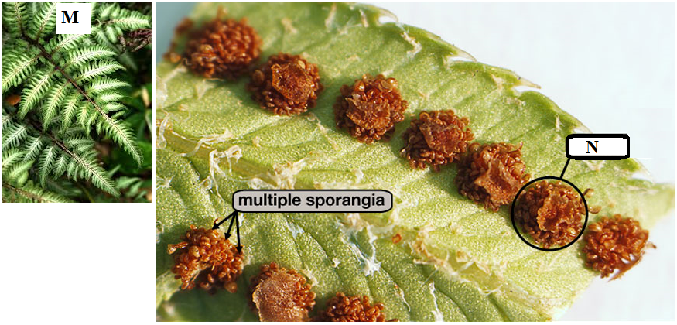
- (i) Name the plant organ represented by the photograph. (1 mark)
……………………………………………………………………………………………………… (ii) Name part label N. (1 mark)
………………………………………………………………………………………………………
(iii) State the function of part labeled N. (1 mark)
…………………………………………………………………………………………………………………
(b) Using observable features give two reasons to explain the Division to which the specimen belongs. (3 marks)
Division
………………………………………………………………………………………………………
Reasons
………………………………………………………………………………………………………………………………………………………………………………………………………………………………………………………………………………………………………………………………………………………
(c) State three non observable characteristics of members of the Division mentioned above (3marks)
………………………………………………………………………………………………………………………………………………………………………………………………………………………………………………………………………………………………………………………………………………………
……………………………………………………………………………………………………………………………………………………………………………………………………………………………………
(i) Which generation of the plant is represented by the photograph? Give a reason. (2 marks)
……………………………………………………………………………………………………………………………………………………………………………………………………………………………………
(ii) Give the name of the structure that produces sperm for this plant. (1 mark)
………………………………………………………………………………………………............
- You are provided with a photograph of an organ system of a mammal.
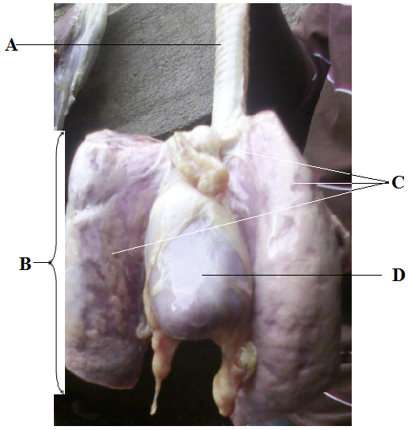
(a) (i) Name the organ system represented by the photograph. (1 mark)
……………………………………………………………………………………….………………………
(ii) State the function of the organ system named in 3(a) above. (1 mark)
………………………………………………………………………………………………………………
(b) Name the parts labeled A, B and C (3 marks)
A ……………………………………………………………………………….
B ……………………………………………………………………………….
C ……………………………………………………………………………….
(c) (i) What is the function of part labeled A. (1 mark)
…………………………………………………………………………………………………………………
(ii) State 4 ways in which structure labeled D is adapted to its function. (4 marks)
………………………………………………………………………………………………………………………………………………………………………………………………………………………………………………………………………………………………………………………………………………………
(d) (i) State three features that adapt structure B to its function. (3 marks)
………………………………………………………………………………………………………………………………………………………………………………………………………………………………………………………………………………………………………………………………………………………
e) State three adaptations of the part labelled D (3marks)
………………………………………………………………………………………………………………………………………………………………………………………………………………………………………………………………………………………………………………………………………………………
(f) Describe how air moves from the atmosphere until it gets into structure B and finally into the blood. (7 marks)
………………………………………………………………………………………………………………………………………………………………………………………………………………………………………………………………………………………………………………………………………………………
…………………………………………………………………………………………………………………
………………………………………………………………………………………………………………………………………………………………………………………………………………………………………………………………………………………………………………………………………………………
…………………………………………………………………………………………………………………
…………………………………………………………………………………………………………………………………………………………………………………………………………………………………………………………………………………………………………………………………………………………………………………………………………………………………………………………………………
This Is The Last Printed Page.

