Name………………………………………..………….…… Adm.No. ……..……….… Class …….……….

231 BIOLOGY
(General paper)
December 2012
1 ½ hours
HOLIDAY SCHOOL
Final Examination 2012 Form Three

INSTRUCTIONS
This paper has ONE section ONLY
Answer ALL the questions in this paper
All answers should be written in the spaces provided on the question paper.

Questions (70 marks)
- The diameter field of view of a light microscopic is 3.5mm. Plant cells lying of the diameter are 10. Determine the size of one cell microns (1mm = 1000µm) (2mks)

- The table below shows the concentration of some ions in pond water and in the cells sap of an aquatic plant growing in the pond.
Ions | Concentration in pond water (parts per million) | Concentration in cell sap (parts per million)
Sodium  Potassium  Calcium  Chloride | 50  2  1.5  180 | 30  150  1  200

a)Name the processes by which the following ions could have been taken up by this plant. (2mks)
i) Sodium ions

ii) Potassium ions

b)For each processes named in (a) (i) and (ii) above, state one condition necessary for the process to take place. (2mks)

- Photosynthesis takes place in two stages.
- Name the part of the chloroplast where
- Light stage occurs

ii) Dark stage occurs (2mks)

b) How is dark stage dependant on the light stage of photosynthesis? (1mks)

5. In an investigation, the pancreatic duct of a mammal was blocked. It was found that the blood sugar regulation remained normal while food digestion was impaired. Explain these observations. (3mks)

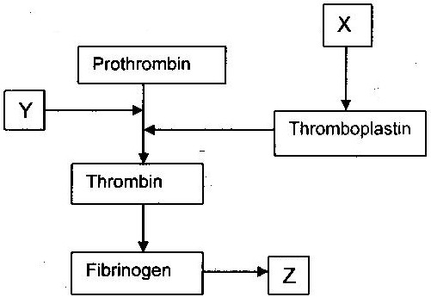
6. The chart below is a summary of the blood clotting mechanism in man.

Name
i) The blood cells represented by X (1mk)

ii) Metal ion represented by Y (1mk)

iii) The end product of the mechanism represented Z (1mk)

7. Name three gaseous constituents involved in gaseous exchange in plants. (3mks)

8. A process that occurs in plants is represented by the equation below.
C₆H₁₂O₆ 2C₂ H₅OH) + (2CO₂) + Energy
Glucose Ethanol Carbon Dioxide
a) Name the process (1mk)

b) State one economic importance of process name in (a) above. (1mk)

9. Explain why some desert animals excrete uric acid rather than ammonia. (2mks)

10. How would one find out from a sample of urine whether a person is suffering from diabetes mellitus?(2mks)

11. (a) Name the fluid that is produced by sebaceous glands (1mks)

(b) What is the role of sweat on the human skin? (2mks)

12. a)Beside the abdomen, name the other body part of members of arachnida (1mk)

- Name the phylum whose members possess notochord. (1mk)

13. What is the importance of the following in an ecosystem? (2mks)
    - Decomposers

    - Predation

14. After four months of pregnancy the ovaries of a woman can be removed without terminating pregnancy. However during the first four months of pregnancy the ovaries must remain intact if pregnancy is to be maintained. Explain these observations (2mks)

15. The diagram below shows a stage during fertilization in plant
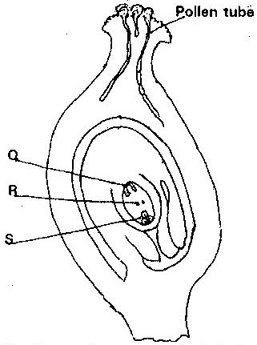

(i) Name the parts labeled R, and S (2mks)

(ii) State one functions of the pollen tube (1mks)

16. Removal of the apical bud from the shrub is a practice that results in the development of the lateral buds which later from the branches.
- Give reasons for the development of the lateral braches after the removal of the apical bud (2mks)

- Suggest one application of this practice (1mk)

- What is the importance of this practice? (1mk)

17. In an experiment to determine the effect of ringing on the concentration of sugar in phloem, a ring of bark
from the stem of a tree was cut and removed. The amount of sugar in grammes per 16cm³ piece of bark above
the ring was measured over a 24 hour period. Sugar was also measure in the bark of a similar stem of a tree
which was not ringed. The results are shown in the table below
Time of the day | Among of sugar in grammes per 16 cm³ piece of bark
 | Normal stem | Ringed stem
06 45 | 0.78 | 0.78
09 45 | 0.80 | 0.91
12 45 | 0.81 | 1.01
15 45 | 0.80 | 1.04
18 45 | 0.77 | 1.00
21 45 | 0.73 | 0.95
00 45 | 0.65 | 0.88

a) Using the same axes, plot a graph of the amount of sugar against time (6mks)
b) At what time was the amount of sugar highest in the;
i) Ringed stem (1mk)

ii) Normal stem (1mk)

c) How much sugar would be in the rigged stem if it was measured at 03 45 hours. (1mks)

d) Give reasons why there was sugar in the stems of both trees at 06 45 hours. (2mks)

e) Account for the shape of the graph for the tree with ringed stem between:
i) 06 45 hours and 15 45 hours (2mks)

ii) 15 45 hours and 00 45 hours (2mks)

f) Other than sugars name two compounds that are translocated in phloem. (2mks)

18. Discuss the role of plant homornes in growth and development in a plant (13mks)

