KAHUHO UHURU HIGH SCHOOL
BIOLOGY DEPARTMENT

NAME………………………………………………………...……..ADM NO…………..……..CLASS……..……

FORM 3 BIOLOGY
PAPER 2
TIME: 2 HOURS

INSTRUCTIONS
Answer all questions in the spaces provided in the paper.

1 a) Distinguish between diffusion and Osmosis (2marks)
………………………………………………………………………………………………………………………………………………………………………………………………………………………………………………………………………………………………………………………………………………………
b) How do the following factors affect the rate of diffusion?
(i) Diffusion gradient (1mark)
……………………………………………………………………………………………………………………………………………………………………………………………………………………………………
(ii)Surface area to volume ratio (1mark)
……………………………………………………………………………………………………………………………………………………………………………………………………………………………………
(iii) Temperature (1mark)
……………………………………………………………………………………………………………………………………………………………………………………………………………………………………
2.The following is a mammalian skin

- (i) Name the parts labeled R and S.
R:………………………………………………
S:……………………………………………… (2 marks)
(ii) State the functions of the parts labeled K and Q. (2 marks)
K………………………………………………
Q………………………………………………
- State two adaptations of the skin of people living on high mountains. (2 marks)
………………………………………………………………………………………………………………………………………………………………………………………………………………………………………………………………………………………………………………………………
3. Removal of the apical bud from the shrub is a practice that results in the development of the lateral buds
which later from the branches.

- Give a reason for the development of the lateral braches after the removal of the apical bud (2mks)
……………………………………………………………………………………………………………………………………………………………………………………………………………………
- Suggest one application of this practice (1 mark)
……………………………………………………………………………………………………………………………………………………………………………………………………………………
- What is the importance of this practice? (1 mark)
……………………………………………………………………………………………………………………………………………………………………………………………………………………

4. ( a) What is meant by the following terms
(i) Protandry (1 mark)
……………………………………………………………………………………………………………………………………………………………………………………………………………………
(ii) Self sterility? (1 mark)
……………………………………………………………………………………………………………………………………………………………………………………………………………………
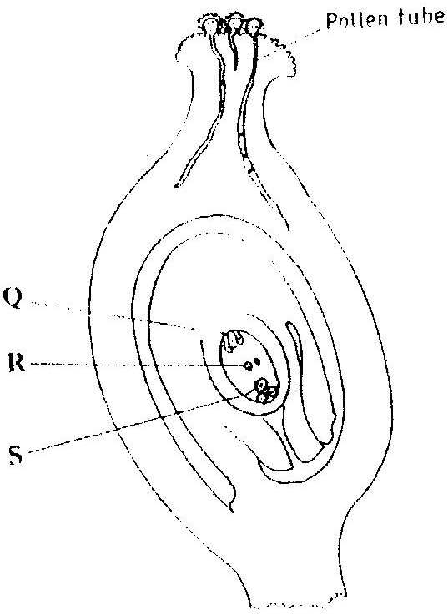
(b) The diagram below shows a stage during fertilization in a plant

(i) Name the parts labeled Q, R, and S ( 3 marks)

Q……………………………………

R……………………………………

S……………………………………

(ii) State one functions of the pollen tube ( 1 mark)
………………………………………………………………………………………………………..
(c) On the diagram label the micropyle ( 1 mark)

SECTION B
Answer question 5 (compulsory) in the spaces provided and either question
6 or 7 in the spaces provided after question 7.

5. Samples of amoeba were mounted on six slides with different concentrations of sodium chloride solution. The average number of times that a contractile vacuole emptied in ten Minutes was recorded.
% sodium chloride | 0.5 | 1.0 | 1.5 | 2.0 | 2.5 | 3.0
No. of vacuoles | 9 | 7 | 5 | 4 | 3 | 2

- Plot a graph of the number of vacuoles against the % sodium chloride. (6 marks)
- (i) What is the function of a contractile vacuole in an amoeba? (1 mark)
……………………………………………………………………………………………….
(ii) What is the habitat of the amoeba used in this experiment? (1 mark)
………………………………………………………………………………………………..
- Account for the difference between the results in 0.5% and 2.5% sodium chloride solution.(2 mks)
……………………………………………………………………………………………….
- In 5% sodium chloride solution, vacuole formation stopped. Suggest and Explain a possible reason for this. (2 marks)
……………………………………………………………………………………………….
……………………………………………………………………………………………….
- Name two forms in which nitrogenous waste is removed in animals (2 marks)
………………………………………………………………………………………………
………………………………………………………………………………………………
(f) Name the organs that carry out the same function as the contractile vacuole in the following
organism:-
- Fish (1 mark)
…………………………………………………
- Man (1 mark)
…………………………………………………
6. A student fed on a meal of ugali and lean meat. Describe its digestion. (12 marks)

7.Discuss the role of hormones in plant growth and development (12 marks)
………………………………………………………………………………………………………………………………………………………………………………………………………………………………………………………………………………………………………………………………………………………
………………………………………………………………………………………………………………………………………………………………………………………………………………………………………………………………………………………………………………………………………………………
………………………………………………………………………………………………………………………………………………………………………………………………………………………………………………………………………………………………………………………………………………………………………………………………………………………………………………………………………………………………………………………………………………………………………………………………………………………………………………………………………………………………………………………………………………………………………………………………………………………………………………………………………………………………………………………………………………………………………………………………………………………………………………………………………………………………………………………………………………………………………………………………………………………………………………………………………………………………………………………………………………………………………………………………………………………………………………………………………………………………………………………………………………………………………………………………………………………………………………………………………………………………………………………………………………………………………………………………………………………………………………………………………………………………………………………………………………………………………………………………………………………………………………………………………………………………………………………………………………………………………………………………………………………………………………………………………………………………………………………………………………………………………………………………………………………………………………………………………………………………………………………………………………………………………………………………………………………………………………………………………………………………………………………………………………………………………………………………………………………………………………………………

