Name………………………………………..…………………….…… Adm.No. …..……….… Class …….…….
KAHUHO UHURU HIGH SCHOOL
231 BIOLOGY
Form 4 Revision Series
Excretion & Homeostasis quiz
Time 80 min

Questions (50 Marks)
- What is meant by the term excretion? (2marks)
…………………………………………………………………………………………………………………………………………………………………………………………………………………………………………………
- Suggest an explanation to each of the following
(a) The kidneys of desert animals have very long loop of Henle (2 marks)
……………………………………………………………………………………………………………………………………………………………………………………………………………………………………………………..…
(b) Fresh water fish excrete ammonia but land animals excrete urea (2 marks)
…………………………………………………………………………………………………………………………………………………………………………………………………………………………………………………………
3. In an accident a victim suffered damage of his internal organs, consequently he started having excess glucose in his blood.
(a) Which organ was damaged? (1mark)
……………………………………………………………………………………………………………….
(b) Give a reason for your answer. (1mark)
……………………………………………………………………………………………………………….
- The figure below shows the body temperature of a person before, during and after taking a cold bath.
(The temperature of the bath water was 22⁰C).
(a) For how long was the person in the bath? (1mark)
………………………………………………………………………………………………………………
- Explain why the person’s body temperature decreased (1mark)
………………………………………………………………………………………………………………………………………………………………………………………………………………………………………

( c) Explain the role played by the following in helping to return the body temperature to normal.
(i) The liver (1mark)
………………………………………………………………………………………………………………
(ii) The blood vessels in the skin (1mark)
………………………………………………………………………………………………………………
(iii) The Skeletal muscles (1mark) ………………………………………………………………………………………………………………
- How would one find out from a sample of urine whether a person is suffering from diabetes mellitus? (2 marks)
……………………………………………………………………………………………………………………………
……………………………………………………………………………………………………………………………
- Explain the term negative feedback (2marks)
……………………………………………………………………………………………………………………………
………………………………………………………………………………………………………………………….…
- a) Name the excretory product in the liver that is used in the intestine. (1 mark)

b) State two functions of the above waste product named in (i) above. (2marks)

- Explain the part played by each of the following in homeostasis:- (2 marks)
  - Insulin

  - Glucagon

9. How are the following conditions brought about (3marks)
a) diabetes Inspidus

b) Diabetes mellitus

c) Liver cirrhosis

- Desert mammals for example Kangaroo rat and Camel survive in areas with very scarce Water.
- State one physiological adaptation of these mammals that enable them survive for long hours without drinking water. (2 marks)

- How is their loop of Henle different from that of other mammals surviving in areas of more water.(1 mark)

(i) Name the gland that secretes antidiuretic hormone (1 mark)

(ii) Explain how antidiuretic hormone assists the mammalian body to regulate osmotic pressure. (3 marks)

- Name the disease that results due to insufficient production of Antidiuretic hormone. (1 mark)

11. The diagram below represents a mammalian nephron
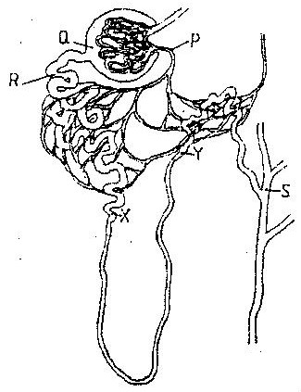

(a) Name the
(i) Structure labeled P (1mark)

(ii) Portion of the nephron between point X and Y (1mark)

(b) Name the process that takes place at point Q (1mark)

12. Describe the homeostatic function of the body to glucose regulation (4 marks)

6. Identify five plant waste products and state their economical importance to man (10 marks)

