GATITU MIXED SECONDARY SCHOOL
FORM 4 JUNE MIDTERM EXAM 2014
MATHEMATICS
INSTRUCTIONS
Answer ALL questions in section I and ANY OTHER FIVE from section II
SECTION I
- Using logarithms tables only evaluate 4mks
2.935×0.0765
3 3.274

- A piece of land is represented on a map by a rectangle 6cm by 4cm. The scale of the map is 1:1000. The land owner sold it for Kshs 150 000 per hectare. How much did he get 3mks

- Simplify 15x² +11x - 12 12x² + x -20 3mks

- A rectangle measures 12.4cm by 7.6cm. Find the percentage error made in calculating the perimeter 3mks

- Find the coordinates of the centre and the radius of a circle with equation x²-8y-6x+y²=0 3mks

- Make S the subject of the formula R = a p 3mks
3b K-S

- Use the reciprocal tables to evaluate 3 7 to 2 decimal places 0.4516 24.83 3mks

- Expand (1-1/2x)⁸ up to the term in x³. Hence or otherwise find the approximate value of (0.95)⁸ correct to 2 decimal places 4mks

- The second and fifth terms of a geometric progression are 81 and 3 respectively. Determine the first term and common ratio of the series; hence find the sum of the first 5 terms. 4mks

- John deposited sh. 40,000 in a fixed a fixed deposit account for a period of 18 months. The bank pays compound interest on quarterly basis at an interest rate of 16%. Determine the amount of money in John’s account after this period 4mks

- Without using mathematical tables evaluate log 41 + log 70 –log 41 + 2log5 35 2 2mks

- Jane and Winnie did a piece of work together. Winnie worked for 9 days working for 6 hours each day. Jane took 12 days working for 8 hours each day to do the rest of the work. Their payment for all the hours worked was sh. 3000. Calculate how much each got. 3mks

- A variable Y is partly constant and partly varies as X. If X=4 when Y=0 and X=12 when Y=40, find an equation connecting Y and X. 3mks

- A train 128m long takes 8 sec to completely pass over a bridge 32m long. Find the speed of the train in kilometers per hour. 3mks

- Without using the mathematical tables 2 tan 45° -tan60° rationalize the denominator 4 sin 30° + 3 3mks

- A cylindrical tank is 20cm thick. Its external diameter is 2.5m and its internal height is 3.6m. How many litres of water will it hold when1/3 full? 2mks

SECTION II
- (a) A bag contains 5 red balls and 3 green balls. A ball is selected at random its colour noted and then replaced. A second ball is then selected. Using atree diagram, find the probability of selecting
- Two red balls 3mks

- One red ball and one green ball 2mks

(b) Two dices are thrown and the product of the numbers on top solved.
(i) Draw a table to determine the probability space 3mks

(ii) From your table determine the probability of having a product that is a prime number 1mk

- Use the table to determine the probability of having a product that is a multiple of 6 1mk

- In the triangle OAB below, C divides AB in the ratio 1:2; D divides the line CO in the ratio 2:3. If OA = a and OB = b

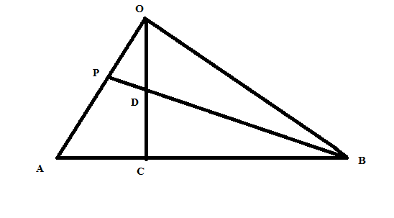

(a) Write the following vectors in terms of a and b
(I)BA

(ii)OC

(iii) BD
(b) If P is a midpoint of line OA, show that B, D and P are collinear 4mks

(c) State the ratio BD to DP (1mk)

19. A ship leaves an island (5N, 45E) and sails due east for 120 hours to another island. The average speed of the ship is 27 knots. Calculate;
(a) The distance between the two islands in; 4mks
(i) Nautical miles

(ii) Kilometers

(b) Calculate the speed of the ship in km/h 3mks

(c) Find the position of the second island (Take 1nm=1.853km) 3mks

20. Muchiri is a married civil servant earning ksh 10000p.m. He has a house allowance shs 1200, commuter allowance shs 3000. Other deductions include; NHIF Shs 250, Insurance policy Shs 300 and NSSF Shs 200. He is also entitled to arelief of kshs 1056 per month. Calculate Mr. Muchiri net pay per month using the table below 10mks
Taxable income Kenya pound p.m. | Rate Kshs per pound
- 165  166-310  311-455  456-600  601 and above | 2  3  5  7  9

21. The table below shows the distribution of marks scored by Form two students in a mathematics test.
Marks No. of students
5-9 1
10-14 2
15-19 3
20-24 2
25-29 9
30-34 6
35-39 4
40-44 2
45-49 1
- Calculate the mean mark 5mks

- Find the median 4mks

- State the modal class 1mk

22. A game ranger leaves his headquarters H for a watching post W, which is 10km from H on a bearing of 030,when he reaches W, he gets a radio call from abearing of 120 to assist a tourist stranded at T. He has to drive 20km to reach T. Using the scale 1:200000 for your drawing
(i) Draw the position of the given places 7mks

II find the distance of T from the headquarters H 2mks

III find the bearing of the headquarters H from T 1mk

